Report on Ayurveda Day Celebration - Run For Ayurveda Rally
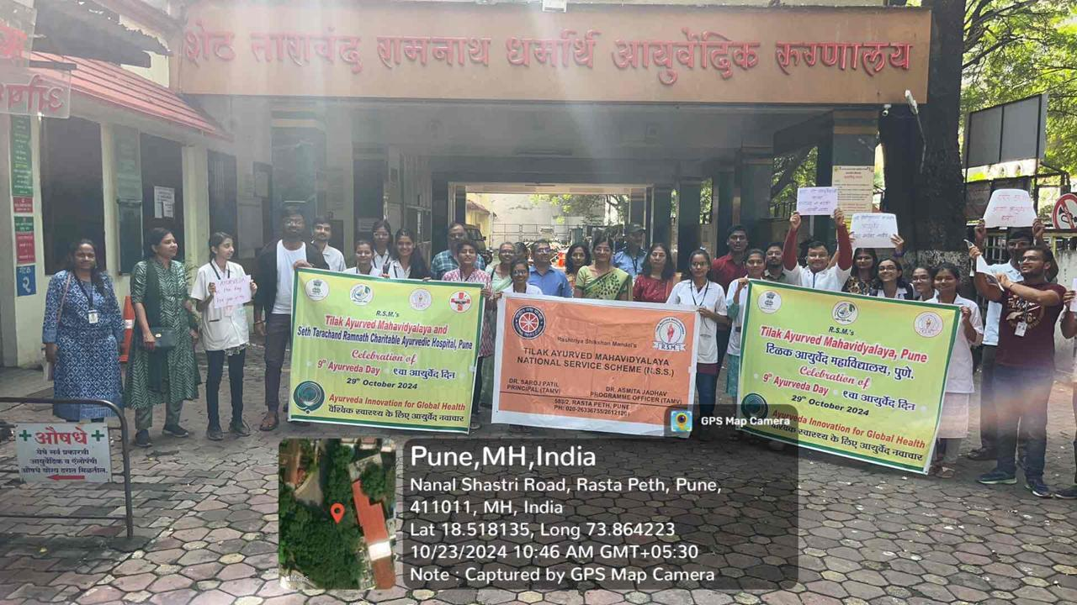

On the occasion of 9 th Ayurveda Day , Tilak Ayurveda Mahavidyalaya has organized the “run for Ayurveda” rally.
NSS department of Tilak Ayurveda mahavidyalaya has organized the programme on 21 /10/2024. The slogans regarding Ayurveda awareness were prepared and students and volunteers from NSS roared the slogans .They emphasised the Importance of Ayurveda among the common people and patients from Tarachand Hospital. Principal Dr.Saroj Patil, Vice principal Dr. Mihir Hajarnavis ,Dr.Randive minakshi ,Dr.Ujagare,Dr.Deshapnde, Dr.Asmita Jadhav ,Dr.Sarika Chopade,Dr.Vinaya dixit, dr.Chopade sarika,Dr.Rucha ganu and other staff participated enthusiastically. Dr.Asmita Jadhav, NSS programme officer and NSS leaders and volunteers coordinated the programme.
