Date: 12/3/2025
Date: 12th March 2025

On 12th March 2025, 54 postgraduate students (2024-2025 admitted batch) and 4 co-ordinators, visited Animal House, Department of pharmacology, Bharati Vidyapeeth, Pune and Rajiv Gandhi Institute of IT and Biotechnology, Bharati Vidyapeeth, Pune as part of an academic initiative to enhance their understanding of in vivo, in vitro, and in silico studies. The visit was structured into two guest lectures and practical demonstrations by eminent experts in the field.

Session 1: Visit and Demonstration of Animal House

- Time: 10:30 AM – 1:30 PM
- Speaker: Dr. Jayashree Dawane
- Venue: Animal House of Department of Pharmacology, Bharati Vidyapeeth, Pune

The visit commenced with an insightful lecture by Dr. Jayashree Dawane, who provided a detailed overview of animal research protocols, ethical considerations, and regulatory guidelines for handling laboratory animals. The students were given demonstration regarding various procedures during animal experimentation and also guided tour of the Laboratory, where they observed the housing conditions, feeding regimens, and handling techniques of various experimental animals. Additionally, they were introduced to preclinical research methodologies used for drug testing and biomedical studies. The session concluded with an interactive discussion on the importance of animal models in translational research.

Session 2: Demonstrations on Cell Culture and In Silico Studies

- Time: 2:30 PM – 5:00 PM
- Speaker: Dr. Alpana Moghe
- Venue: Biotechnology Department, Rajiv Gandhi Institute of IT and Biotechnology, Bharati Vidyapeeth Pune

The afternoon session, conducted by Dr. Alpana Moghe, focused on in vitro and in silico techniques used in modern biomedical research. The session included:

1. Demonstration of Cell Culture Studies – Students were shown the basic techniques of cell culture, including media preparation, aseptic handling, cell passaging, and viability assessment.
2. Demonstration of In Silico Studies – A practical session on computational biology techniques
3. Familiarization with Instrumentation and Procedures – Students were introduced to various equipment and methodologies used in in vitro, and in vivo research.
Dr. Moghe explained how these approaches complement each other in drug discovery and biomedical advancements.

Conclusion

The visit provided a comprehensive learning experience, integrating theoretical knowledge with hands-on exposure to preclinical and computational research techniques. The students gained valuable insights into animal model research, cell culture methodologies, and computational studies, essential for advancing their research capabilities. The interactive discussions and practical demonstrations significantly enriched their understanding of modern biomedical research approaches.

This academic visit successfully bridged the gap between classroom learning and practical applications, fostering a deeper appreciation for experimental and computational research methodologies among postgraduate students.

Visit Co-ordinators:

Dr Asmita Jadhav | Dr Aishwarya Ranade | Dr Neelam Valhekar | Dr Aishwarya Masal
Associate Professor, Department of Dravyaguna | Assistant Professor, Department of Roganidana | Assistant Professor, Department of Agadtantra | Assistant Professor, Department of Agadtantra

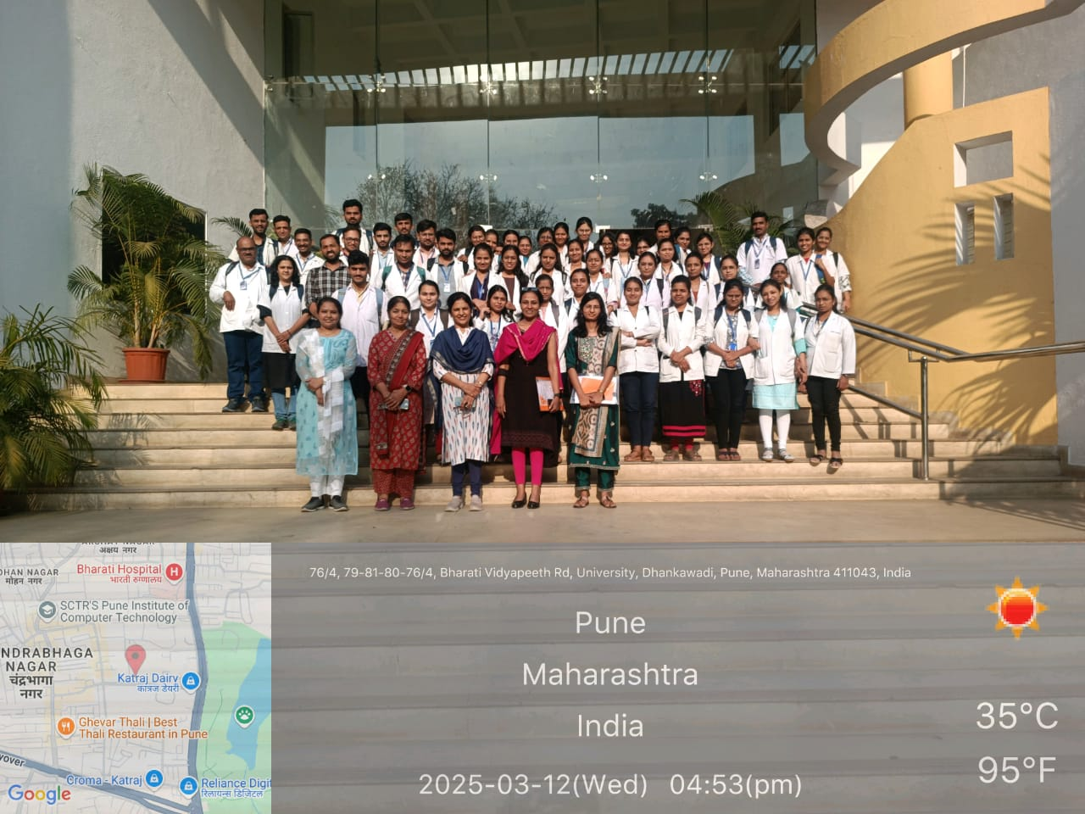 | 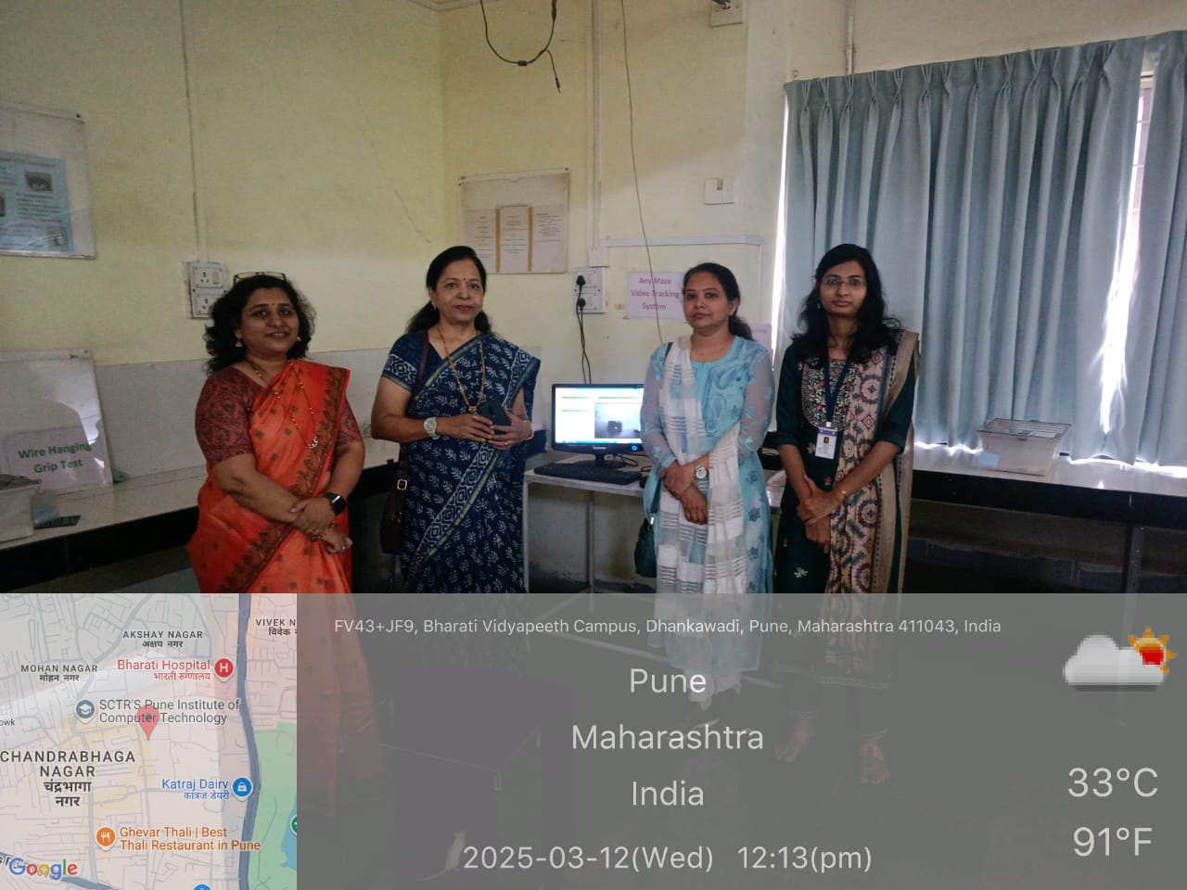
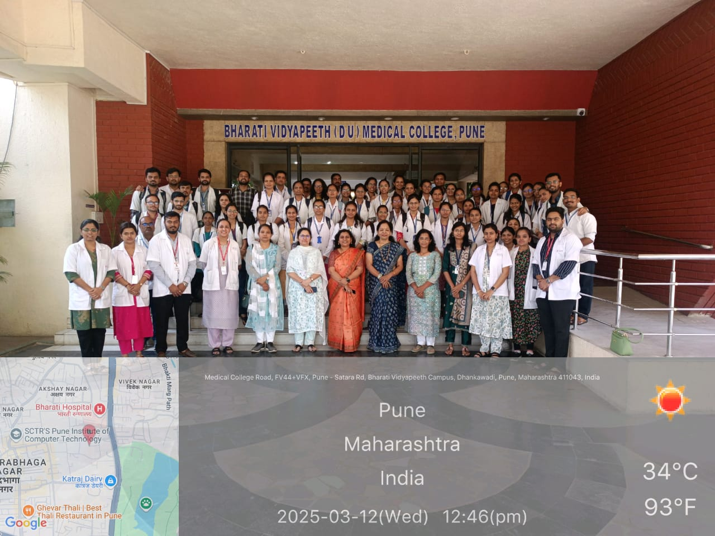 | 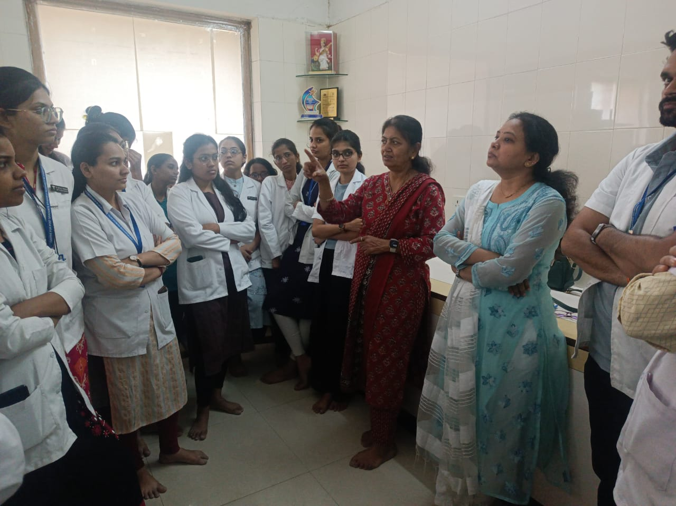

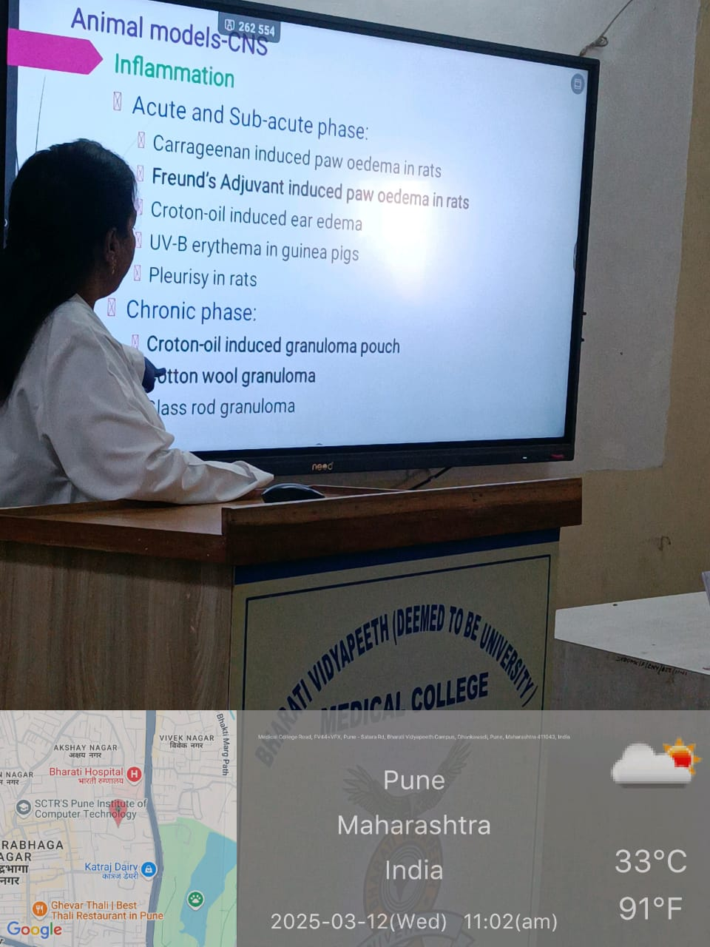 | 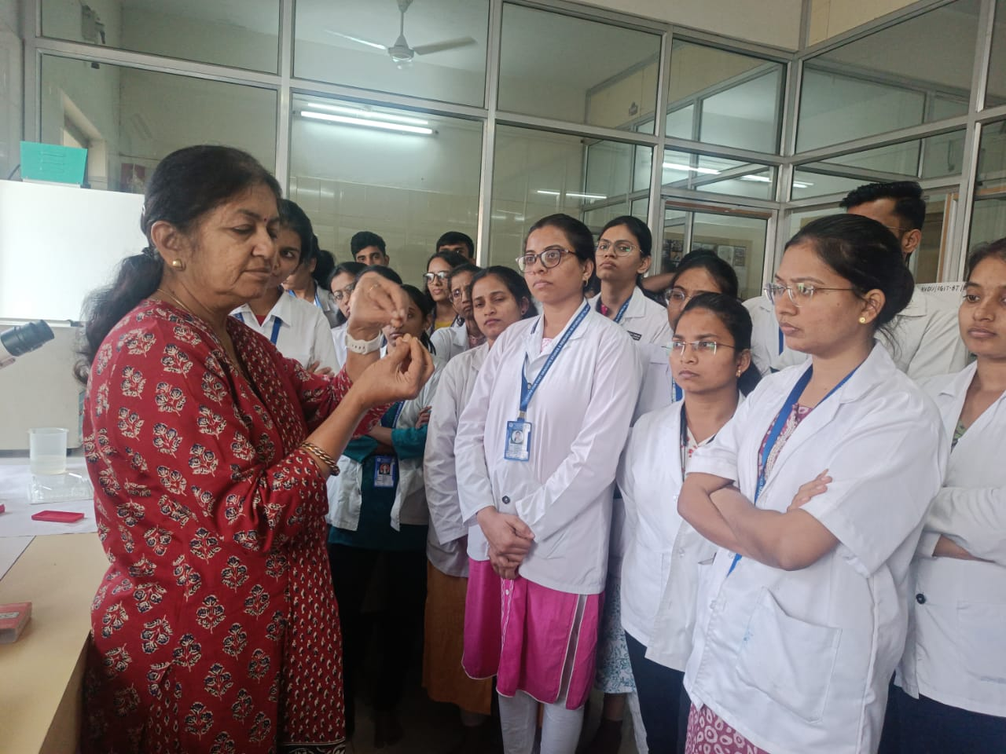
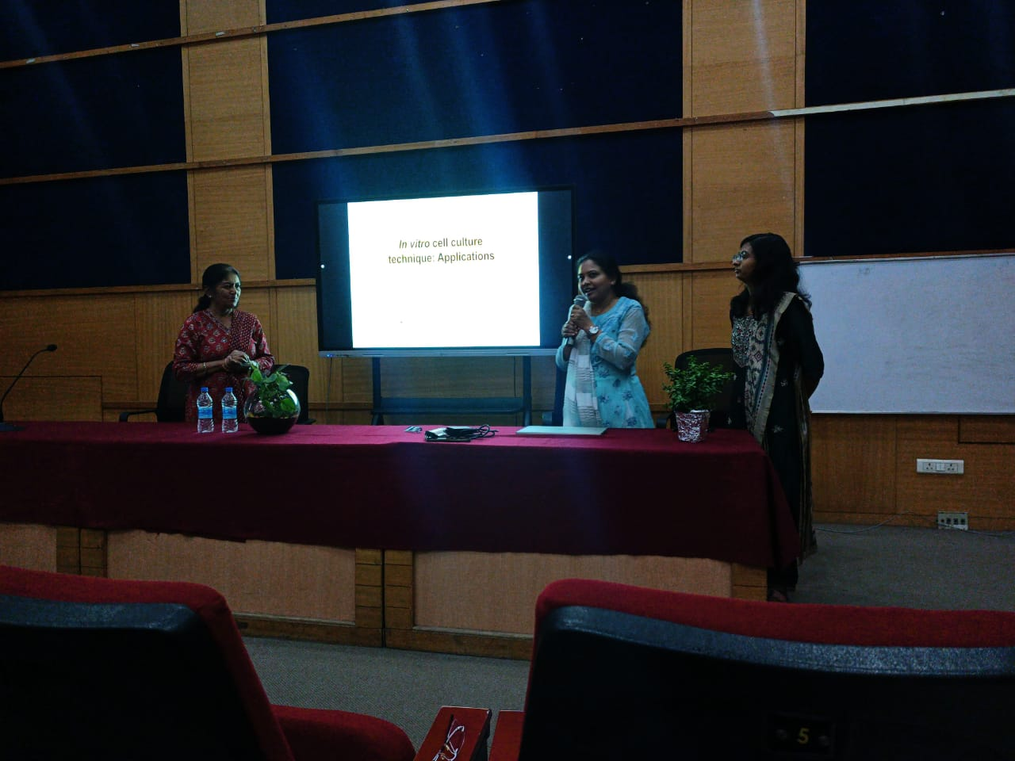 | 