10th Ayurveda day
Tilak Ayurved Mahavidyalaya &
Seth Tarachand Ramnath Charitable Ayurvedic Hospital
Prasuti Tantra & Streerog Department

Name of activity-
Free Health check up and counselling for menstrual disorders & Ayurvedic management.

A free health check up camp was organized by Prasuti Tantra & Streerog Department of Tilak Ayurved Mahavidyalaya in collaboration with
Seth Tarachand Ramnath Charitable Ayurvedic Hospital.
Date- 18th, 19th, 20th September 2025
Venue- OPD no. 11, Tarachand Hospital, Rasta peth, Pune.
The camp was organized for patients having menstrual disorders like dysmenorrhoea, menorrhagia, oligomenorrhoea and polycystic ovarian syndrome.
It was conducted for consecutive 3 days in our institute’s OPD.
All together 45 patients enrolled in this health check up. A thorough history taking and clinical examination was done. Then they were advised investigations and Ayurvedic management.
Additionally, counselling for lifestyle modifications, diet and exercise was also done. Rajaswala paricharya according to Ayurveda was advised to each and every patient.
Consultants Dr. Rucha Ganu, HOD, Associate Professor, Dr. Janhavi Phadke, Assistant Professor & PG Residents- Dr. Sneha, Dr Mayur, Dr. Pratiksha, Dr. Shivani, Dr. Sampada, Dr. Kajal, Dr. Samina, Dr. Nikita, Dr. Divya, Dr. Trupti, Dr. Shubham all actively participated in the health check up.

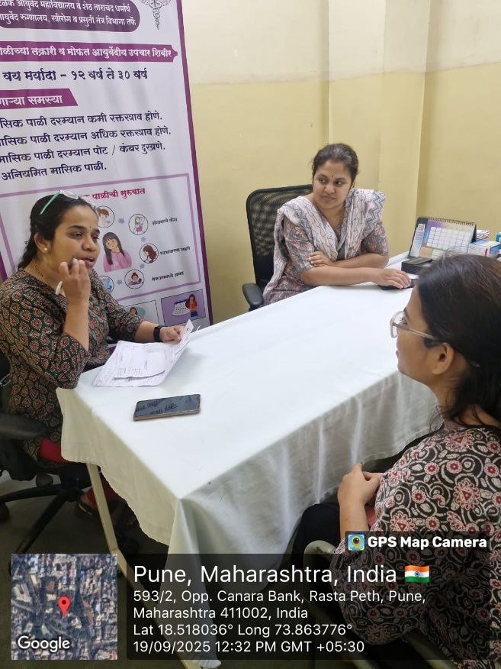
Counselling and dietary advice

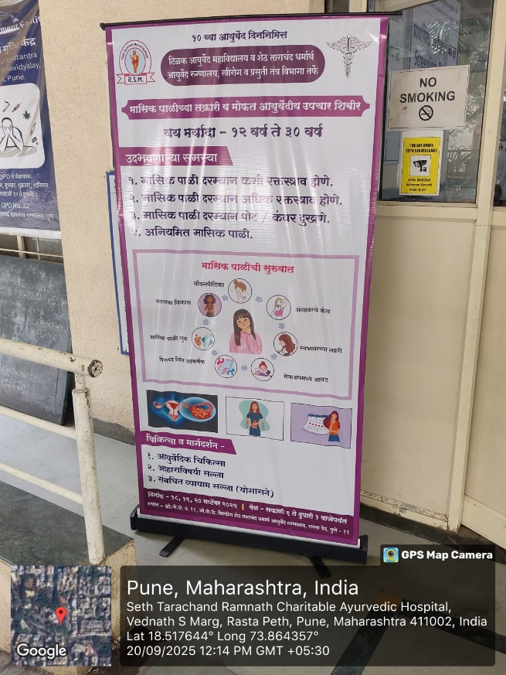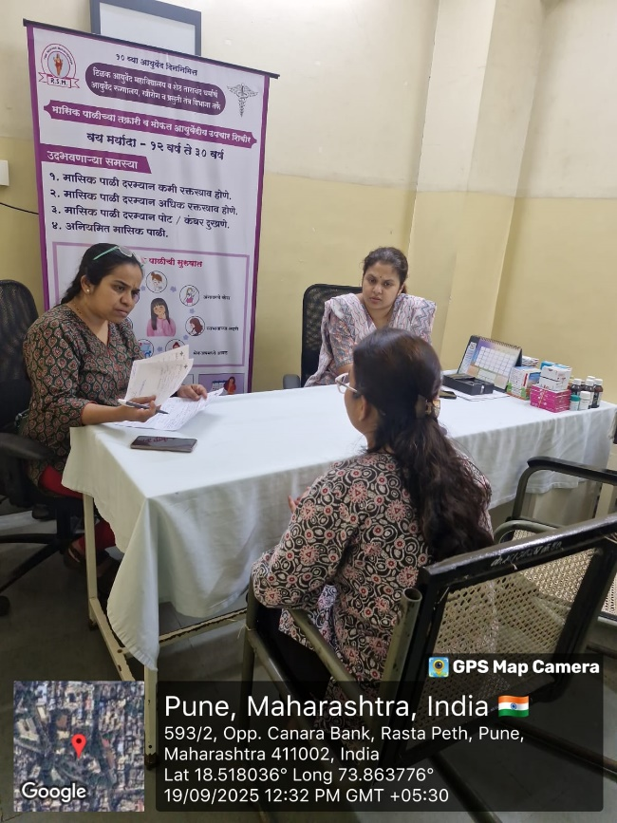

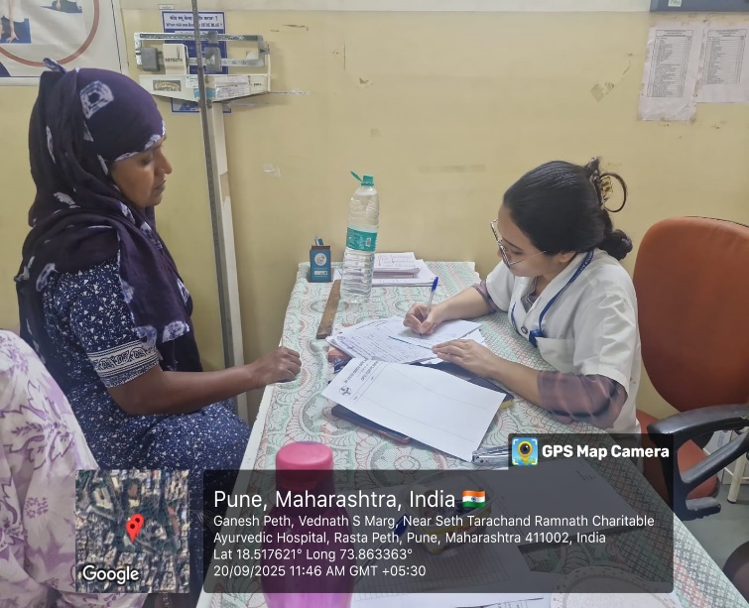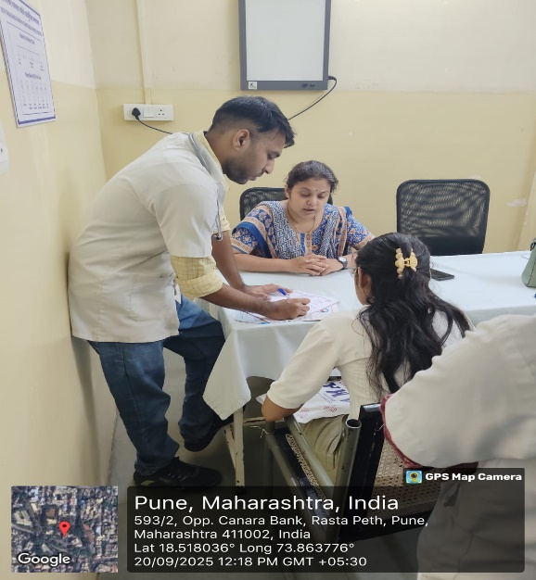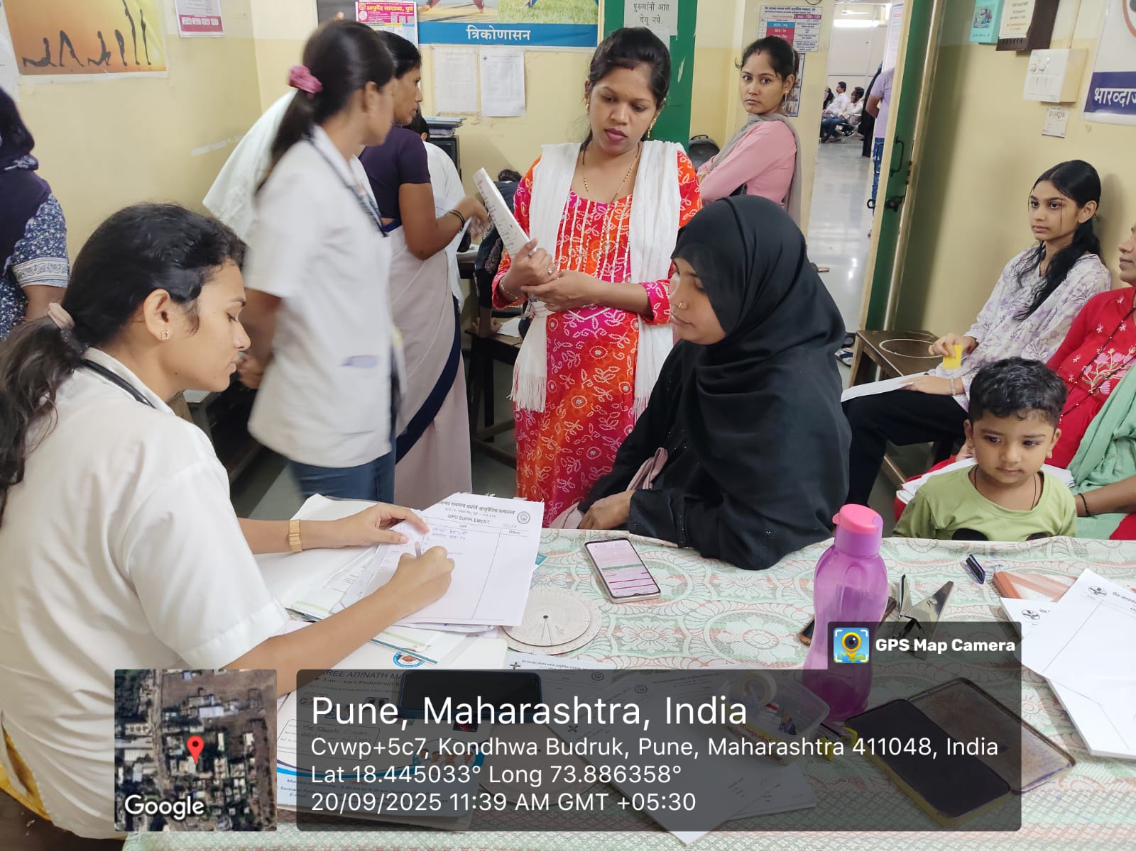
History taking & advice

