Report of Role Play Activity on the Occasion of 10th National Ayurveda Day
Organized by: Tilak Ayurveda Mahavidyalaya, Pune
Suggested by: NCISM and Ministry of AYUSH, Government of India
Venue: Cyrus Poonawala School, Rasta Peth, Pune
Date: 19th September 2025
Time: 11:00 AM – 12:00 PM
Introduction
As part of the activities suggested by NCISM and the Ministry of AYUSH to commemorate the 10th National Ayurveda Day, Tilak Ayurveda Mahavidyalaya, Pune, organized a Role Play Activity to create awareness about Ayurveda among school students. The event aimed to sensitize young minds to the importance of Ayurveda in digital deaddiction and holistic well-being.
Details of the Activity
Total Students Present: 47
Students Participated in Role Play: 16
Faculties Present:
Dr. Neelam Valhekar
Dr. Shilpa Kolarkar
Dr. Aishwarya Masal
The participating students enacted various scenarios demonstrating the role of Ayurveda in digital deaddiction. The role play was designed in a simple and interactive manner so that school students could easily relate to and understand the core concepts.
Outcome
The activity successfully created awareness among the school children regarding:
The preventive and promotive aspects of Ayurveda in digital deaddiction.
The significance of healthy diet, lifestyle, and seasonal regimens (Dinacharya and Ritucharya).
The relevance of Ayurveda in modern times for managing stress, digital addiction, and lifestyle diseases.
The session was interactive, with enthusiastic responses from the audience. Students actively engaged with the performers and asked relevant questions, reflecting their interest and curiosity.
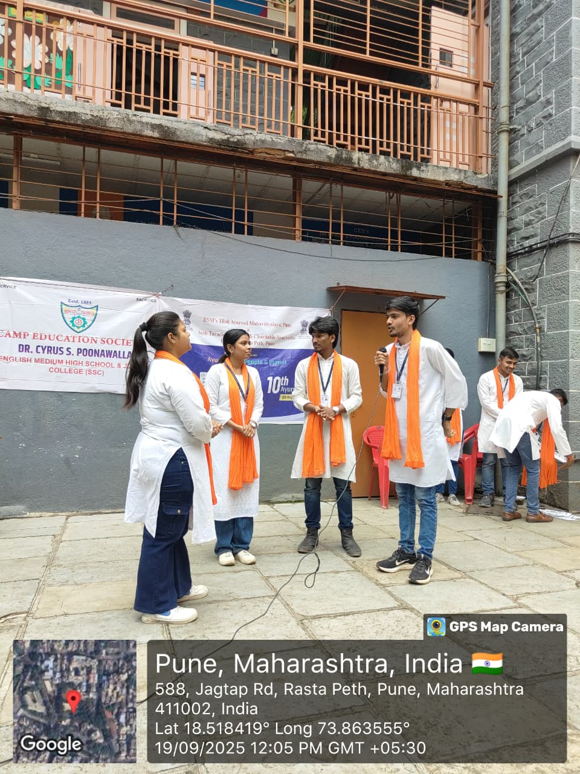

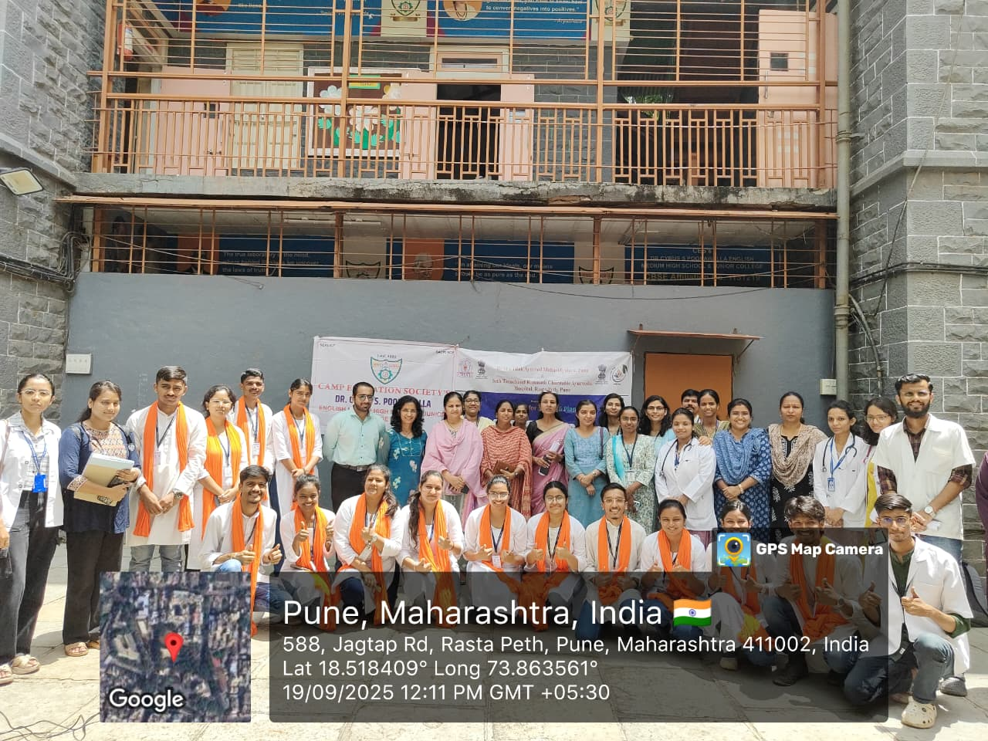

Health Check-up Camp Report

Name of the School: Cyrus Poonavala school, Rasta peth pune
Date: 19/9/25
Organized by: Tilak Ayurved mahavidyalay pune
Conducted by -
Dr. Asmita Jadhav
Dr. Supriya gore
Dr. Neelam Valhekar
Dr. Rucha Ganu
Dr. Ashwini Shinde
Dr. Meghana Phophliya
Dr. Dewashish Umbrajkar
Dr. Yashashree Kulkarni

Introduction:-
On the occasion of 10th National Ayurveda Day,
Health Check-up Camp was organized at Cyrus poonavala school rasta peth pune on 19/9/25 with the objective of assessing the overall health status of school children and promoting awareness about healthy habits. The camp was conducted under the guidance of medical professionals and health staff.

Objectives:-

To identify common health problems among children.
To assess growth and development parameters.

To spread awareness about hygiene, nutrition, and preventive health care.

To refer children with specific health issues for further evaluation and management.

Activities Conducted

1. General Health Examination – Height, weight, BMI, vital signs.

2. ENT Examination – Screening for ear, nose, and throat issues.

3. Gynac Examination - Menstrual problems - Dismenorrhagia , Menorrhagia

4. Nutritional Assessment – Identifying undernutrition/obesity.

5. Health Education Session – Guidance on personal hygiene, handwashing, healthy diet, and physical activity.

Participation

Total students examined: 334

Teachers and staff participated: 20

Conclusion:-
The health check-up camp was highly beneficial for the students. It helped in early detection of common health issues and created awareness about preventive health care. Parents and teachers were advised to follow up on the referrals and encourage children to adopt healthy lifestyle
