TILAK AYURVED MAHAVIDYALAYA
Rasta Peth, Pune Maharashtra

SWASTHA NARI SASHAKTA PARIWAR ABHIYAN
17 SEPTEMBER -2 OCTOBER 2025
MINISTRY OF AYUSH GOVERNMENT OF INDIA

Name of the Activity:
Swastha Nari Sashakta Pariwar Abhiyan was executed by Streerog prasutitantra department of Tilak Ayurved Mahavidyalaya in collaboration with NSS unit of our college and Seth Tarachand Ramnath Ayurvedic Charitable Hospital.
Activities carried out were –health talks and medical check -up camps for adolescent girls cervical and breast cancer awareness sessions ,OPD camps for PCOS , menstrual abnormalities and Antenatal care ,exercises ,dietary advise & counselling for pregnant women

Activity 1 :19th September

A medical camp was organised for adolescent girls from 6th to 9th std in Cyrus Poonawala school,Rasta peth Pune. 80 girls were examined during this medical camp. A general check up,menstrual history ,dietary habits were documented. All post graduate residents and honorary consultant of the department participated actively in this camp. Health talks were organised for the school girls regarding menstrual health.

1) Topic : Menstrual hygiene and dos & don’ts
Speaker : Dr. Rucha Ganu HOD & Asso.Prof. ,Steerog dept

2) Topic : Dietary advise for menstrual health.
Speaker : Dr.Janhavi Phadke Asst. Professor streerog

Health Talk on Menstrual Health
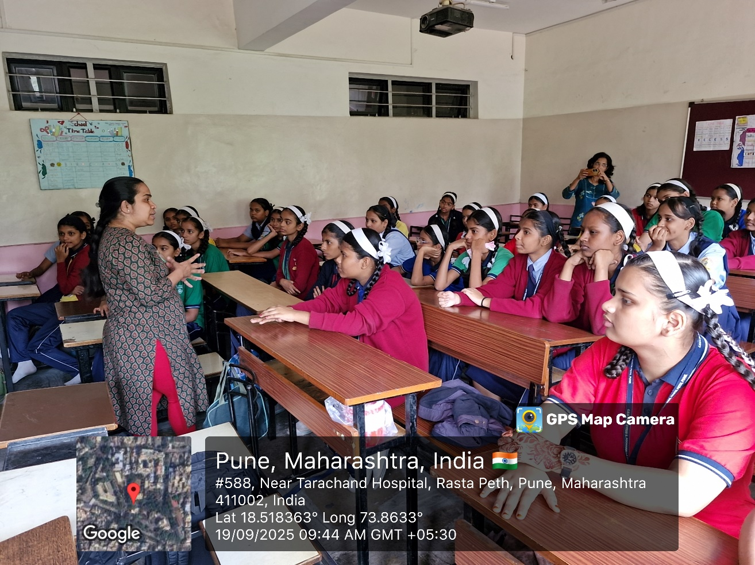

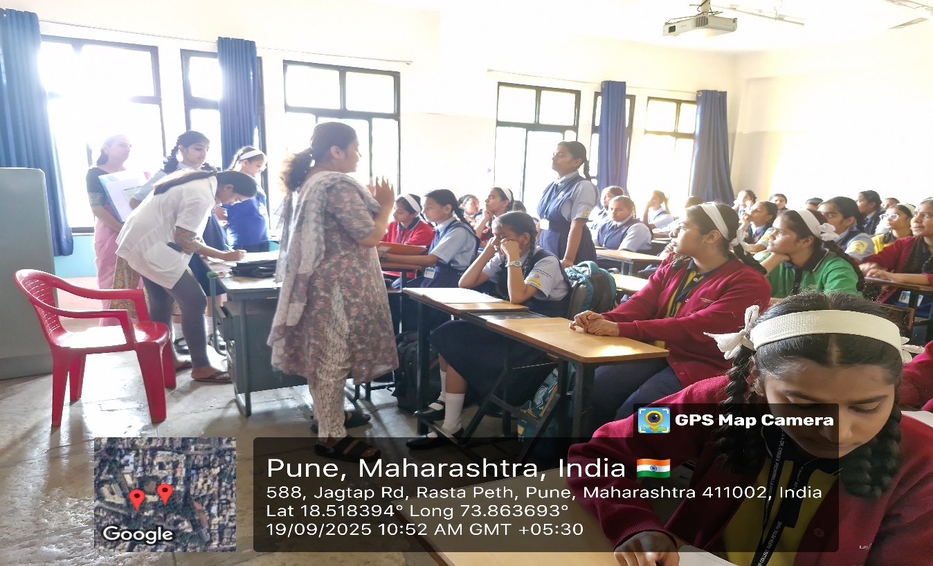

Medical camp
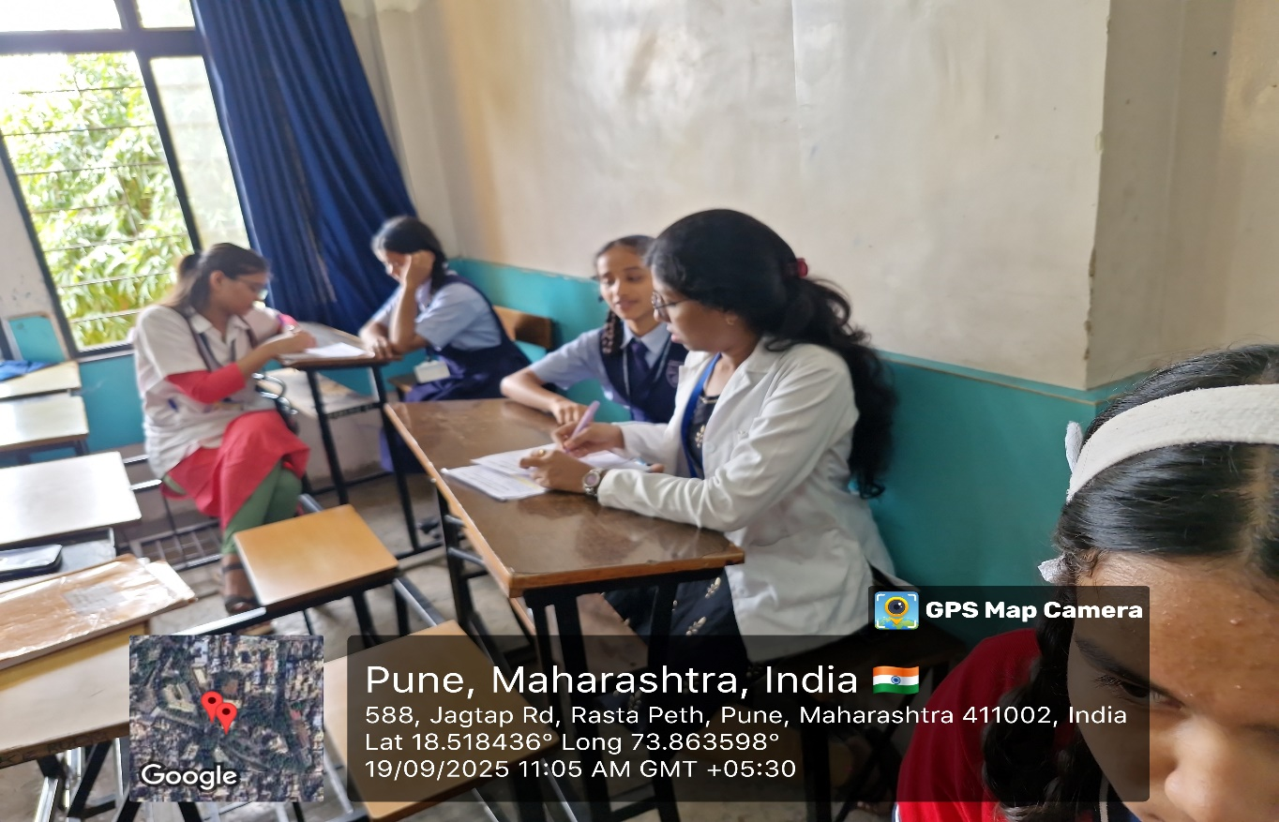

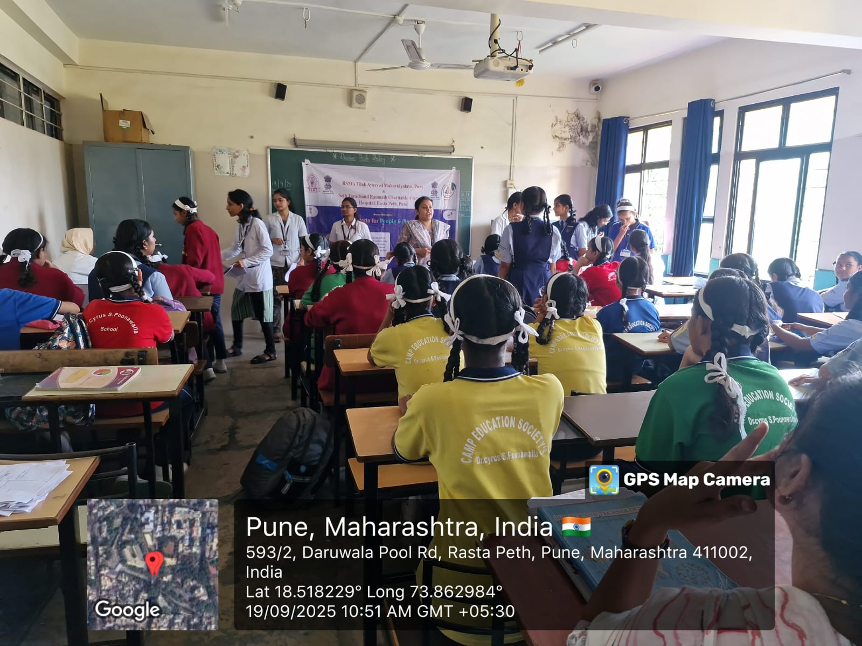
Activity 2 : Awareness programme for breast cancer and cervical cancer.
Date : 24/09/2025
The session for cervical cancer and breast cancer awareness was conducted in OPD of streerog prasutitantra of our hospital Seth Tarachand Ramnath Charitable Ayurvedic Hospital .Total 26 participants were present for the session.

1st session : Cervical cancer awareness – Everything about ca cervix
Sign & symptoms,PAP smear, vaccine when to report was explained
Speakers : Dr. Rucha Ganu HOD & Asso.Prof. ,Steerog dept
Dr.Pratiksha,Dr. Shivani (PG resident)

2nd session : Breast cancer awareness – Everything about ca Breast
Sign & symptoms,screening – Mammography, Self breast examination was explained
Speakers :Dr.Janhavi Phadke Asst. Professor streerog
Dr. Rucha Ganu HOD & Asso.Prof. ,Steerog dept
Dr.Sneha (PG resident)

Cervical and breast cancer awareness programme
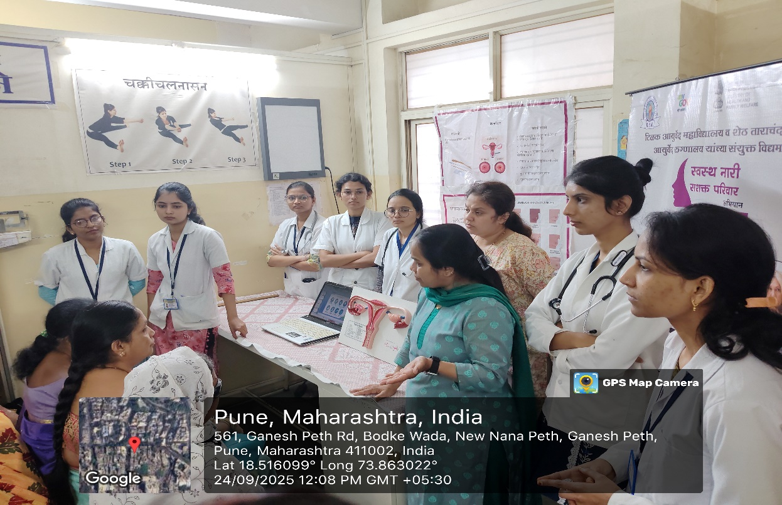

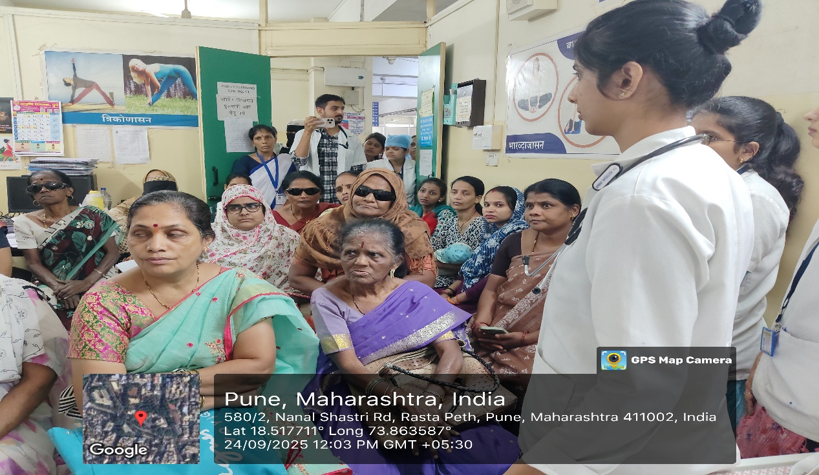

Cervical and breast cancer awareness programme
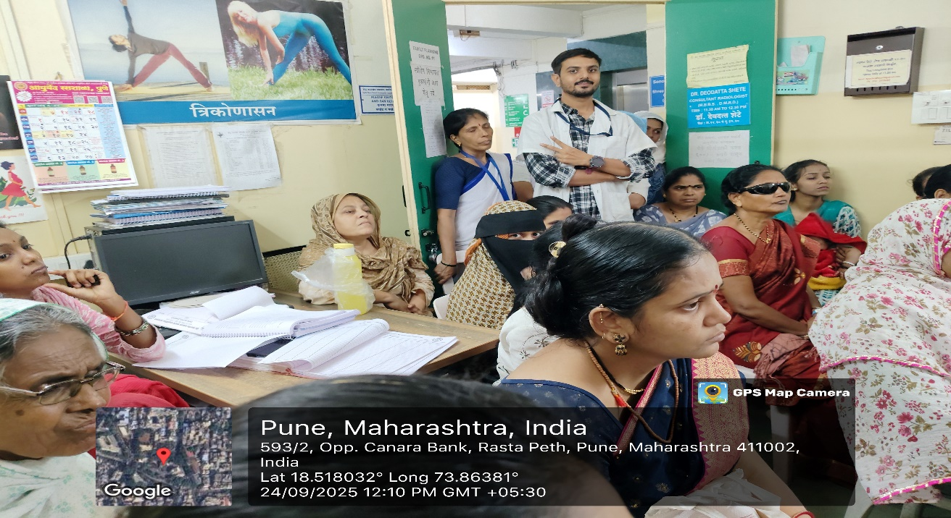

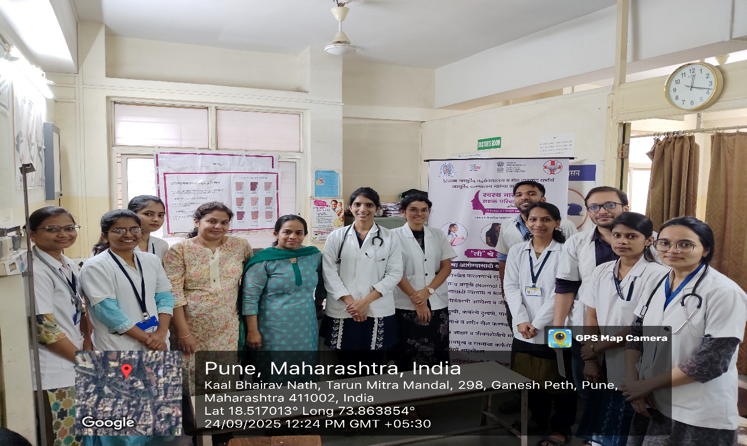

Activity no 3 : Free Health check up and counselling for menstrual disorders & Ayurvedic management.

A free health check up camp was organized by Prasuti Tantra & Streerog Department of Tilak Ayurved Mahavidyalaya in collaboration with Seth Tarachand Ramnath Charitable Ayurvedic Hospital.
Date- 18th, 19th, 20th September 2025
Venue- OPD no. 11, Tarachand Hospital, Rasta peth, Pune.

The camp was organized for patients having menstrual disorders like dysmenorrhoea, menorrhagia, oligomenorrhoea and polycystic ovarian syndrome.It was conducted for consecutive 3 days All together 45 patients enrolled in this health check-up.
A thorough history taking and clinical examination was done. they were advised investigations and Ayurvedic management.
Additionally, counselling for lifestyle modifications, diet and exercise was also done. Rajaswala paricharya according to Ayurveda was advised to each and every patient.

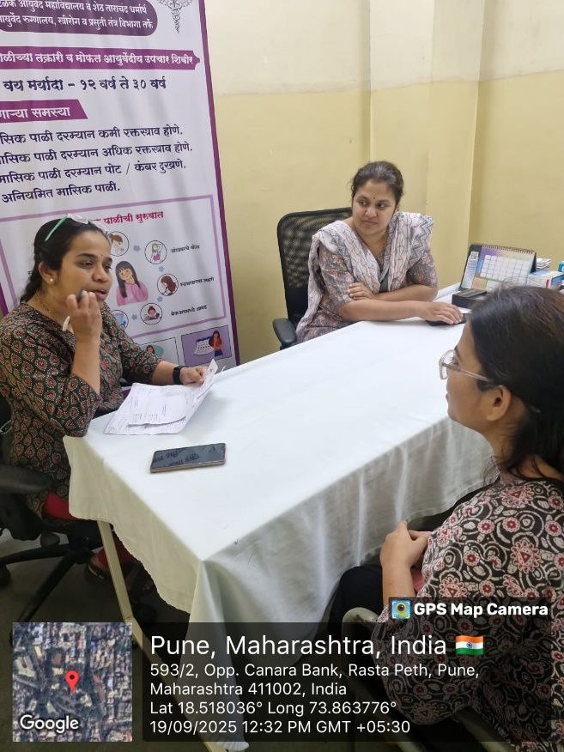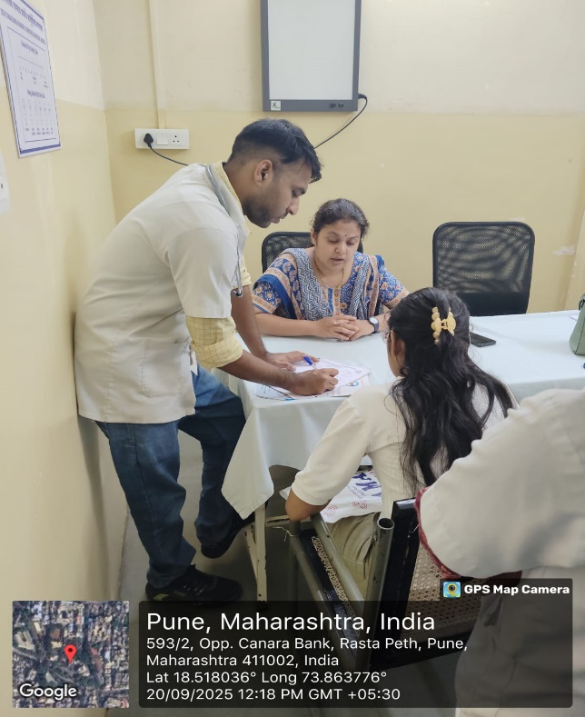

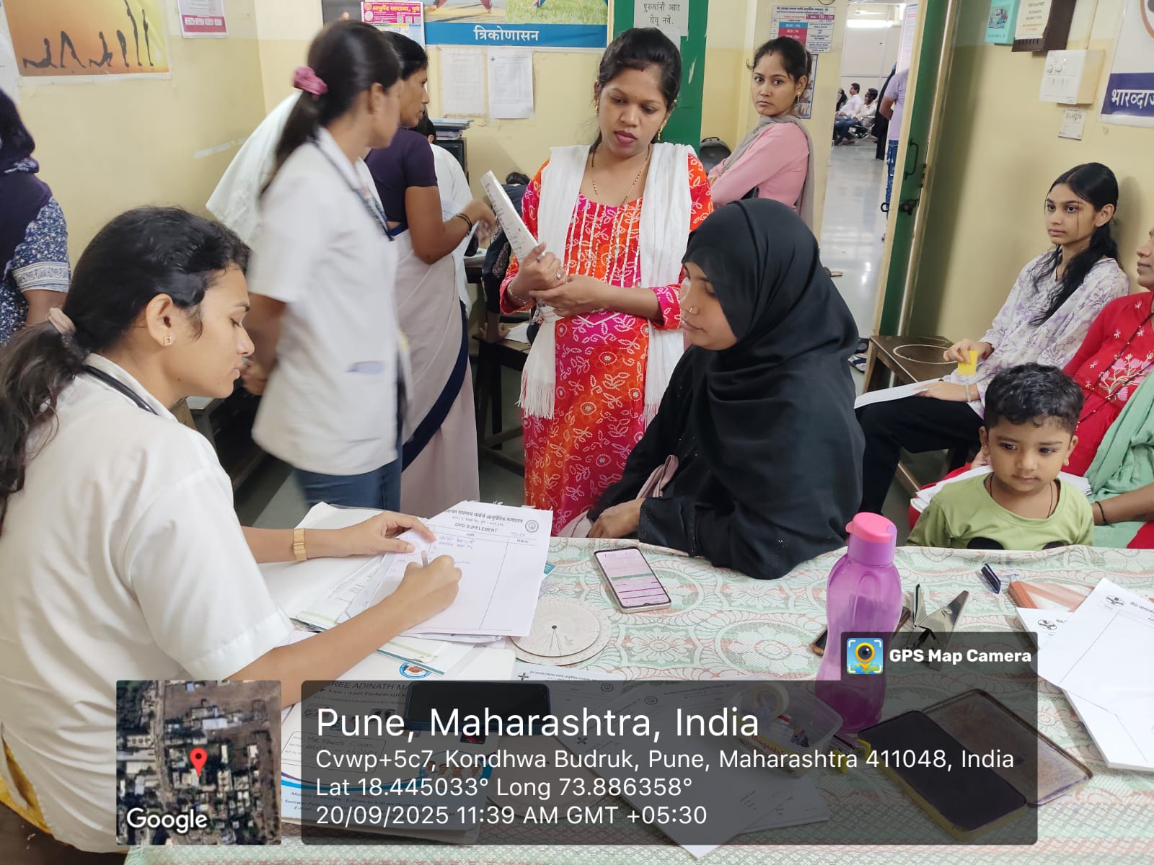
History taking & advice

Activity 4 : Exercise (Physiotherapy) , diet and medication in Antenatal period

A joint venture was organised for ANC patients by Streerog prasutitantra department and Physiotherapy department. Of MES college of physiotherapy.Total 22 pregnant patients participated in the session.
Session 1: Exercises in three trimester of Antenatal period.
Speaker: Dr .Abha and team
She explained importance of exercise relaxation techniques and poses for normal labour. They demonstrated different poses .
Session 2 : Diet & medication
Dr.Rucha Ganu .Dr.Janhavi Phadke, Dr. Mayur conducted the session.

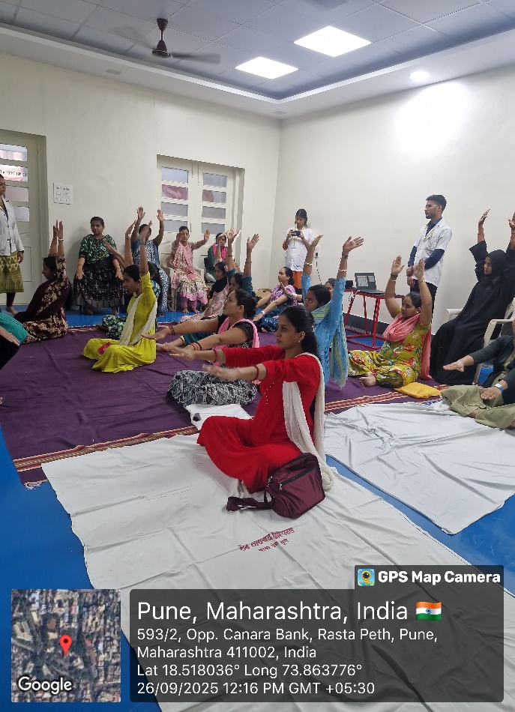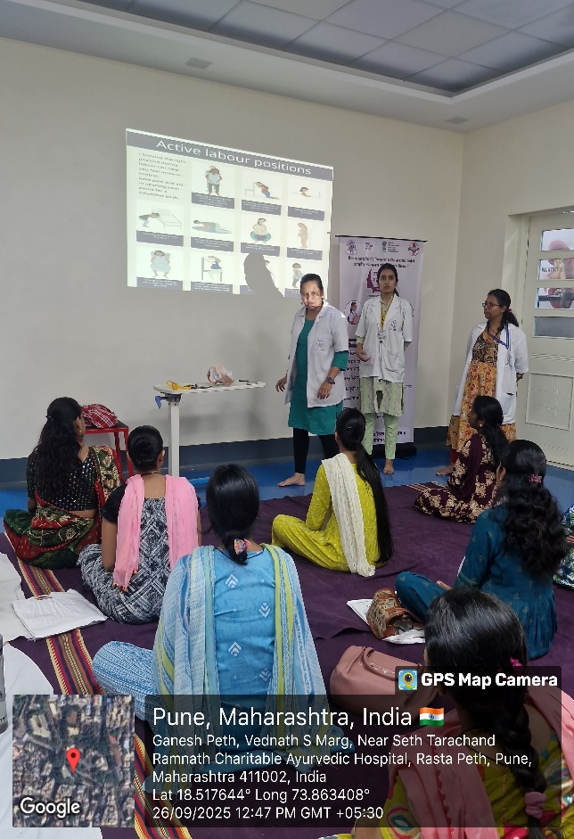

Demonstration and training of exercises in ANC
