Report of Free Health Camp for Anorectal Diseases
Shalyatantra Department.

On the auspicious occasion of Ayurveda Day celebrated on 23 September 2025, a Free Health Camp for Anorectal Diseases was organized by Sheth Tarachand Ramnath Charitable Ayurvedic Hospital,Pune and Tilak Ayurveda Mahavidyalaya Pune Shalyatantra Department. The camp aimed to provide awareness, early diagnosis, and treatment of common anorectal disorders while promoting the principles of Ayurveda in healthcare.
Inauguration of Health Camp was done by Hon.Dr.Nandkishor Borse and Hon Dr.Kalyani Bhat.
Objectives:
To create awareness about anorectal diseases such as piles (hemorrhoids), fissure-in-ano, fistula, pilonidal sinus, and abscess.
To offer free anorectal examination and consultation by qualified Ayurvedic and surgical specialists.
To distribute free medicines and educate patients on preventive measures and Ayurvedic management.

Activities Conducted:
The camp began with a brief inaugural session highlighting the significance of Ayurveda Day and the role of Ayurveda in the prevention and treatment of anorectal disorders. The camp was conducted by our professionals Dr Nandkishor Borse, Dr Dhanraj Gaikwad, Dr Vinod Shet,Dr Dipak Poman, Dr.Omkar Jyotik, Dr.Monali Deshmukh and Dr. Chitali Dhomade

Registration & Screening: Patients were registered and basic health details were recorded.
Clinical Examination: A total 37 patients were examined by expert doctors. Detailed anorectal examinations, including per rectal and proctoscopic assessments, were carried out confidentially.

Counseling & Education: Patients were educated about dietary habits, lifestyle modifications, and the importance of early treatment. Special emphasis was given to high-fiber diet, adequate hydration, and Ayurvedic therapies such as Ksharasutra for fistula and piles.A Health Talk organized and speech given by Hon .Dr.Nandkishor Borse

Free Medicine Distribution: Ayurvedic medicines, stool softeners, pain relievers, and ointments were distributed free of cost to all diagnosed patients.
Outcome:
The camp received an overwhelming response from the community, with 37 beneficiaries receiving examination and free medicines.
Conclusion:
The Health Camp organized on Ayurveda Day proved to be a significant step in community health promotion. By integrating Ayurvedic principles with clinical care, the camp successfully spread awareness, offered treatment, and encouraged preventive health practices for anorectal diseases. Such initiatives not only help in early detection and management but also promote the rich heritage of Ayurveda in modern healthcare.

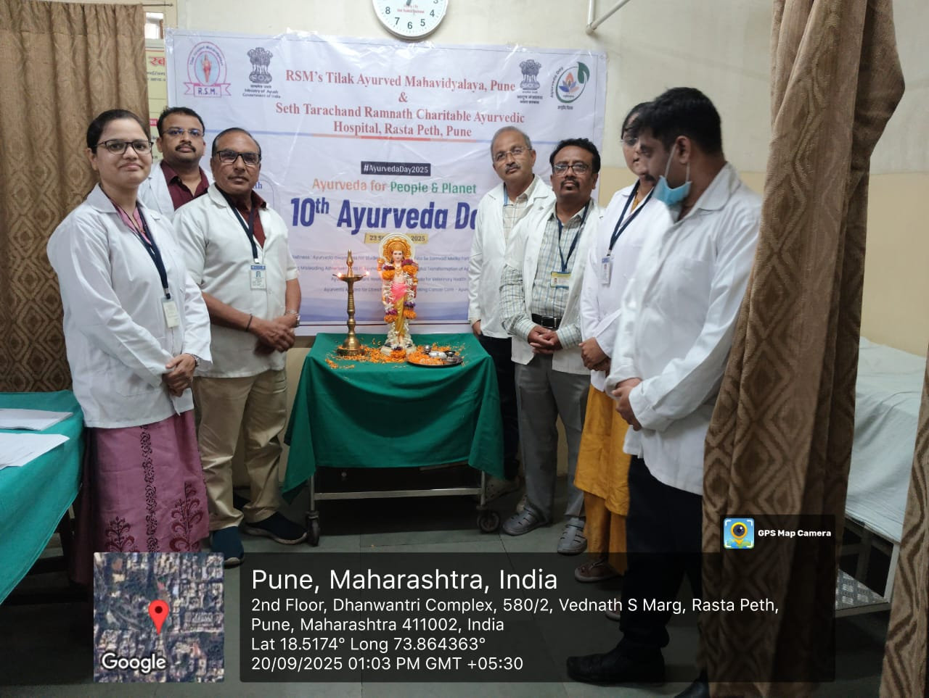
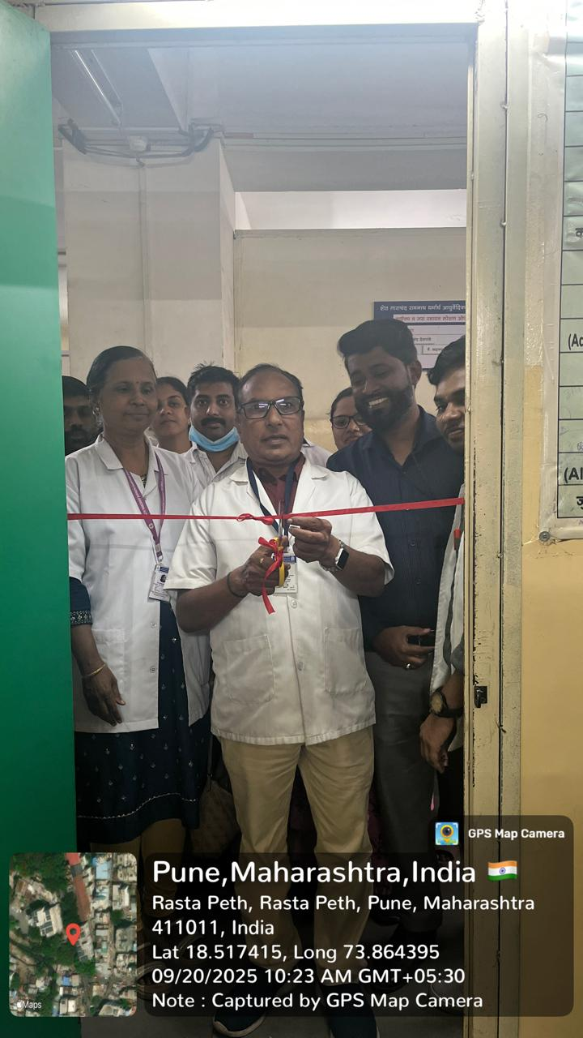
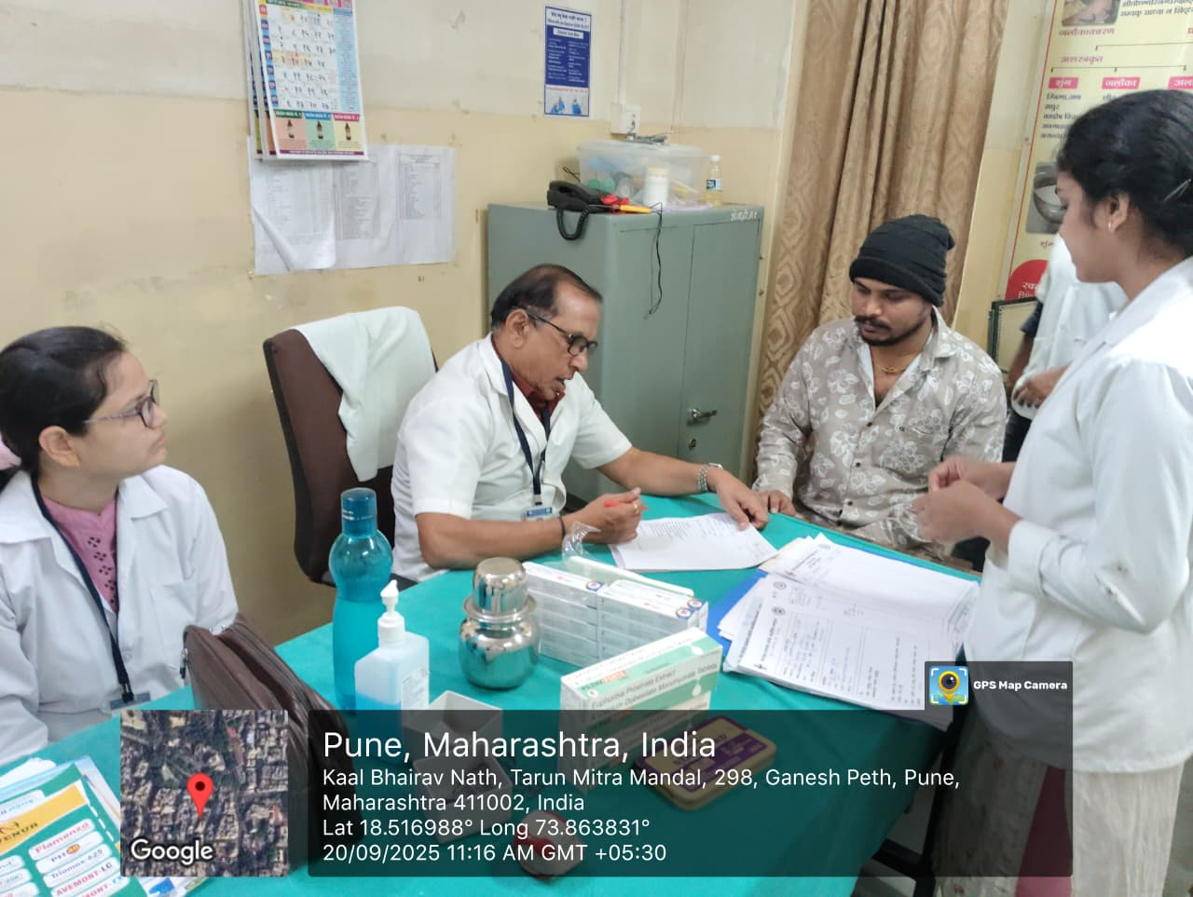

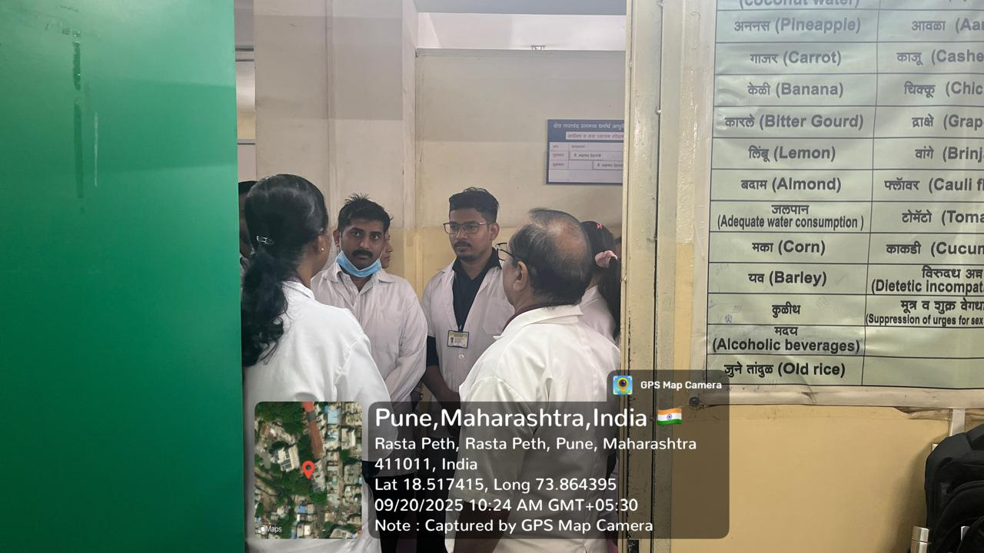
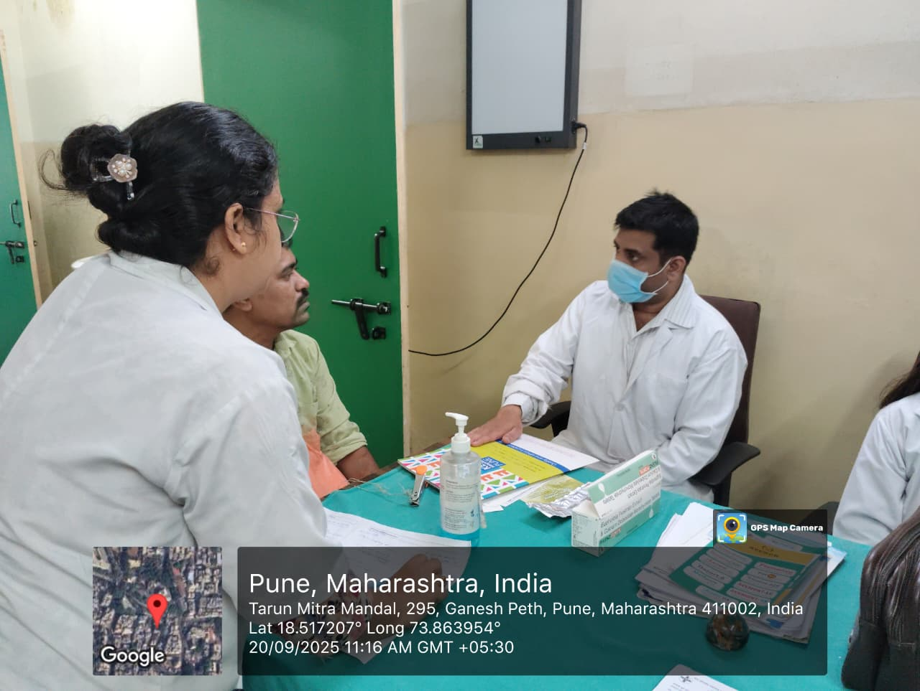

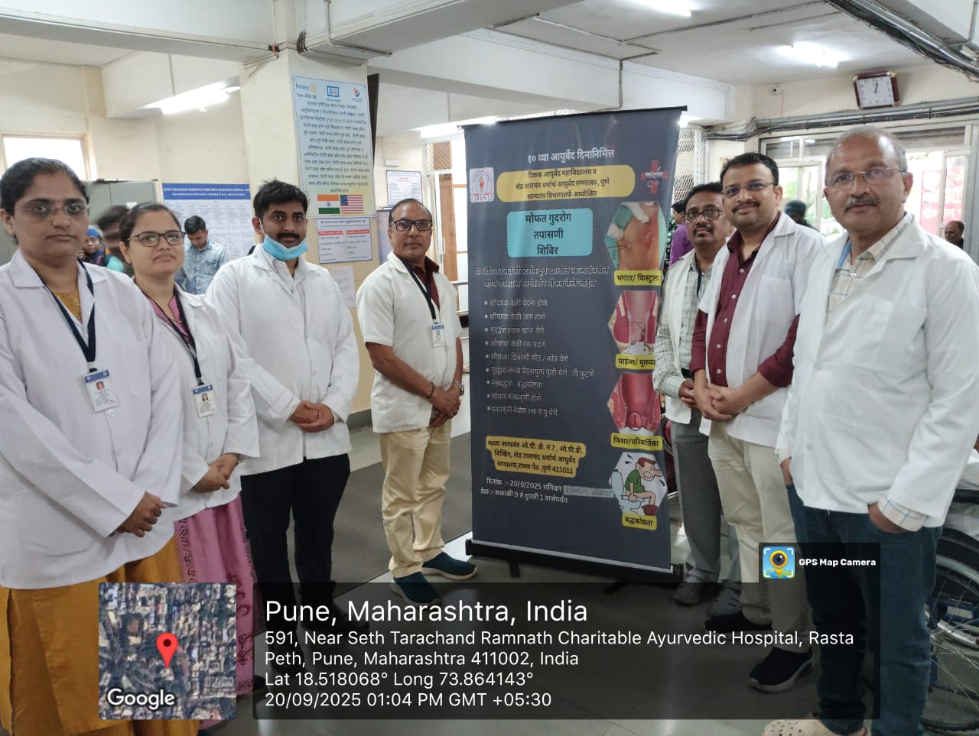

Exhibition on occasion of 10 th National Ayurveda Day

Exhibition on occasion of 10 th National Ayurveda Day on 20th September. Exhibition was organized by Tilak Ayurveda Mahavidyalaya and Seth Tarachand Ramnath Charitable Ayurvedic Hospital. Exhibition had objectives of
Awareness on prevention of surgical diseases. Awareness about signs and symptoms of Piles . Dietary and lifestyle modifications for prevention of surgical diseases were promoted.

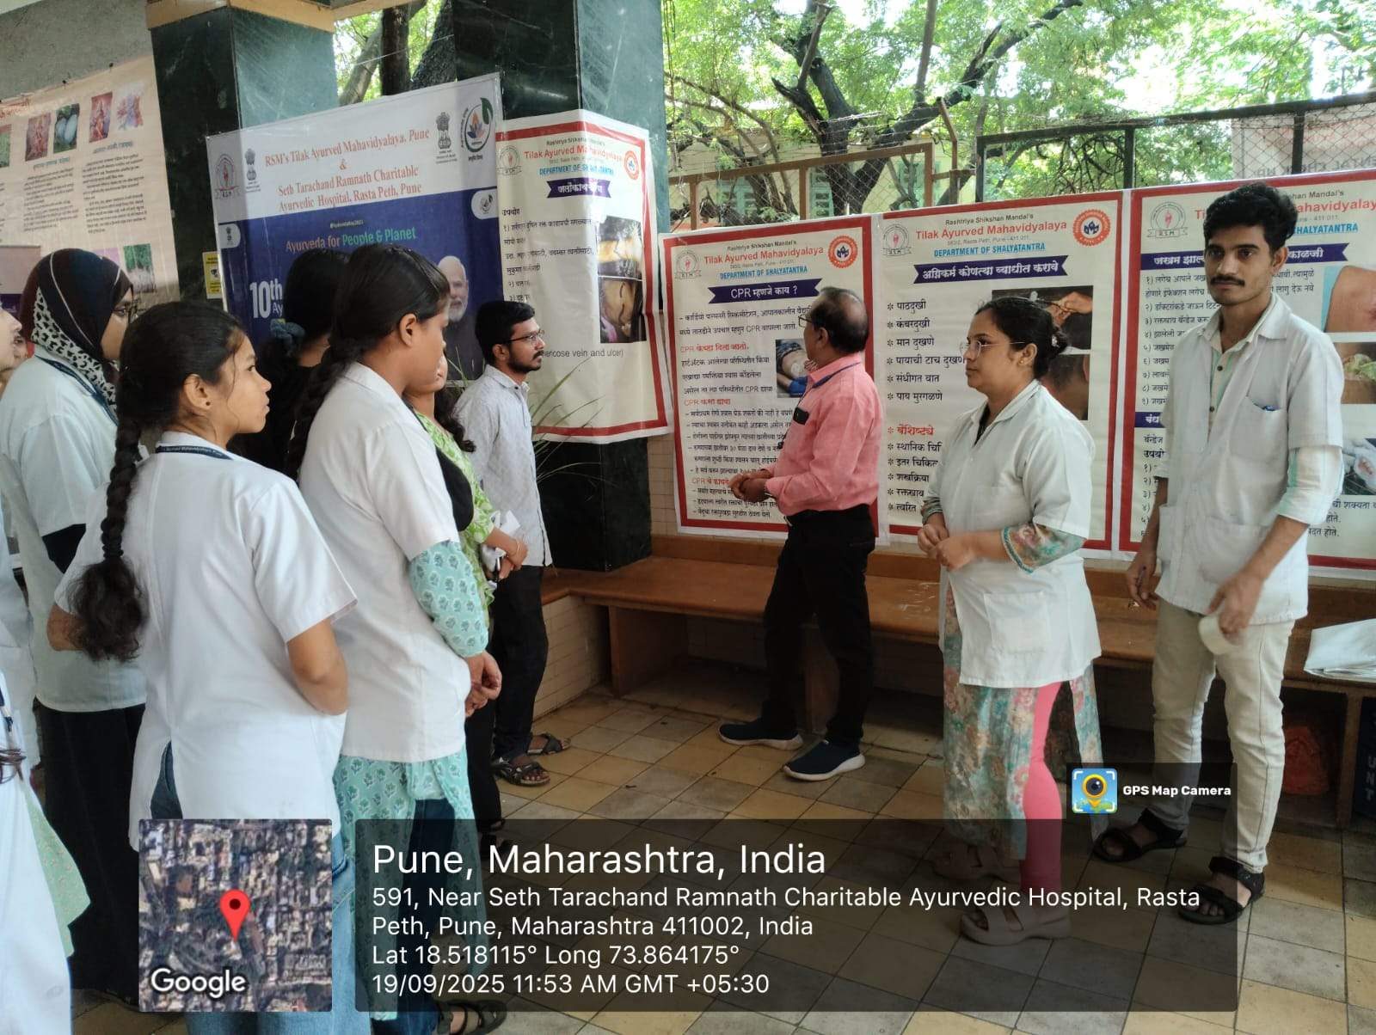

Report of The health talk on "Prevention of Piles"

The health talk on "Prevention of Piles" was organized by Tilak Ayurveda Mahavidyalaya and Seth Tarachand Ramnath Charitable Ayurvedic Hospital on September 20, 2025, as part of the 10th National Ayurveda Day celebrations.

Event Highlights
- *Topic*: Prevention of Piles
- *Speaker*: Dr. Nandkishor Borse
- *Organizers*: Tilak Ayurveda Mahavidyalaya and Seth Tarachand Ramnath Charitable Ayurvedic Hospital
- *Date*: September 20, 2025
- *Occasion*: 10th National Ayurveda Day

About the Organizers
- *Tilak Ayurveda Mahavidyalaya*
- *Seth Tarachand Ramnath Charitable Ayurvedic Hospital*
- Dr Nandkishor Borse sir gave advise to common people on following topic
- *Ayurvedic Approach*: Emphasis on dietary changes, herbal remedies, and Panchakarma therapies for piles management.
- *Lifestyle Modifications*: Importance of regular exercise, stress management, and healthy habits in preventing piles.
- *Preventive Measures*: Discussion on preventive strategies, including fiber-rich diets and adequate hydration.
Importance of surgery was even told to patient.

