Report on World Ayurveda Day Health Camp
Camp Dates: 17th to 19th September 2024
Occasion: World Ayurveda Day (23rd September 2024)
Organized by: Department of Kayachikitsa
On the occasion of World Ayurveda Day 2024, the Department of Kayachikitsa organized a Free Health Check-up Camp from 17th to 19th September 2024 at OPD No. ⑤, OPD Building, Hospital premises.
The camp was specially conducted on the theme of Vata Vyadhi and Sandhigat Vikar Diseases. During this health initiative:
- Patients received free health check-ups and consultations.
- Ayurveda experts provided guidance and awareness regarding the role and importance of Ayurveda in maintaining daily health.
- Emphasis was laid on the preventive and curative aspects of Ayurveda for Vata Vyadhi and Sandhigat Vikar related opportunistic illnesses.
A total of 90 patients benefited from the camp through medical services, advice, and health awareness sessions.
The camp was successfully conducted with the active participation of specialist doctors.
(The list of participating specialist doctors is attached with this report.)
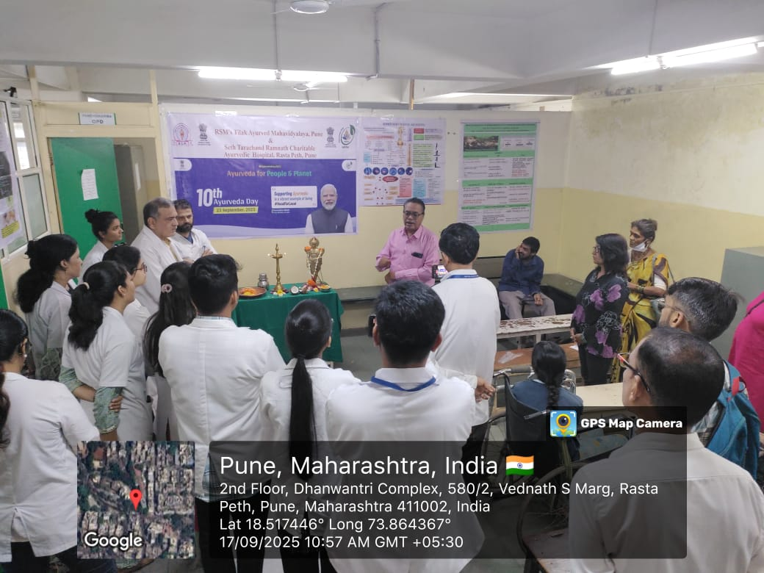
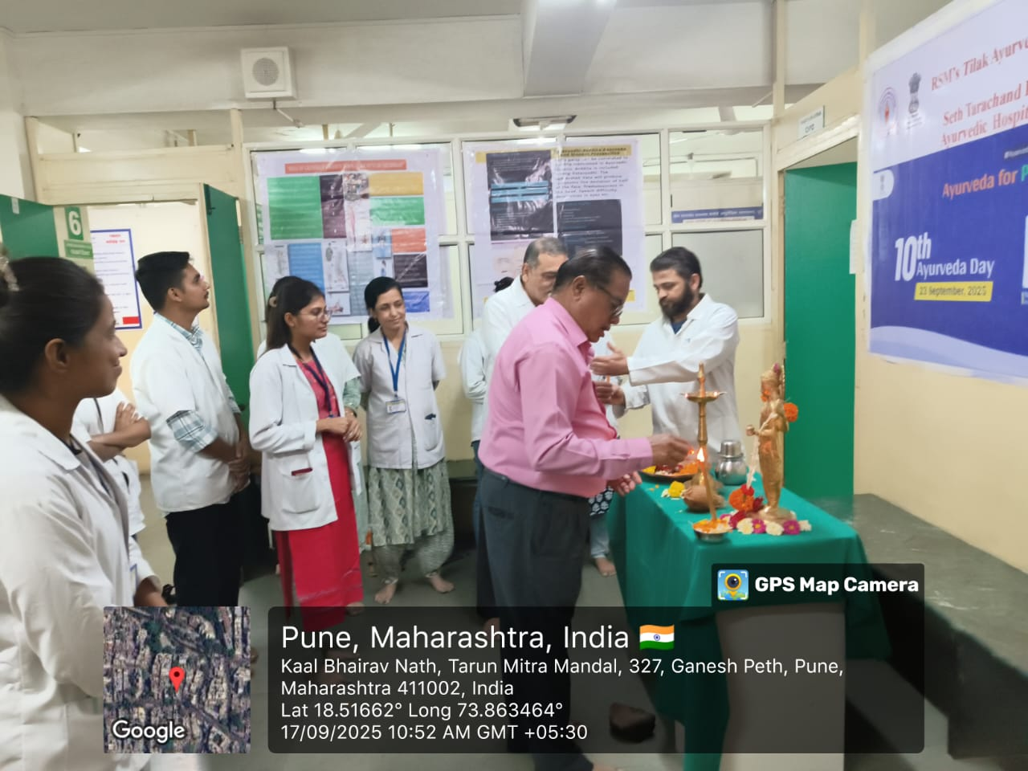
Conclusion:
The health camp proved to be an effective platform to promote Ayurveda-based preventive healthcare and to serve the community by spreading awareness on managing asthma and opportunistic diseases through Ayurveda.
