One Day Departmental Workshop
On
Digitalisation of Rasadravyas: Feb.2026

“Workshop Report”

NAME OF EVENT:
DEPARTMENTAL WORKSHOP: DIGITALISATION OF RASADRAVYA IDENTIFICATION & PHARMACOLOGY.

ORGANIZED BY: KAI.SHRI.AA. MANDKE DEPARTMENT OF RASASHASTRA, T.A.M.V.
DATE OF EVENT: 11TH Feb.2026
OBJECTIVE & DESCRIPTION:
Kai.shri.A.Mandke Dept. of Rashashastra organized a one-day workshop titled “Digitalisation of Rasadravya identification & Pharmacology” on 11th feb. 2026.

The workshop includes theory lectures as well as hands on training with demonstrations of QR code making of pharmacological information of rasadravyas.

This will encourage II B.A.M.S. students & P.G. scholars of the of the institute to develop their Digital skills and Knowledge regarding identification and pharmacotherapeutics of Rasadravya.

The competency-based curriculum by NCISM and M.U.H.S. encourages organization of such activities which will be useful for further career development of Undergraduate Students.

This event was carried out during college hours. A prior permission for the conduction of workshop from the Respected Principal Dr. Saroj Patil was taken and documented.
Also, a prior Informing Notice regarding the conduction of this workshop for the H.O.D.s & Faculties of the second professional B.A.M.S. Batch, appearing in the month of September 2026 was circulated and attendance of the participating Students in this workshop was shared with concerned departments as per regular time table.

RESOURCE PERSON:
- Prof. Dr. Indira Ujagare
- Prof. Dr. Vinaya Dixit
- Prof. Dr. Mandar Akkalkotkar
- Prof. Dr. Ashwini Bodade
- Prof. Dr. Kshitija Kulkarni

PG SCHOLARS:
- Dr. Vikrant Rakshe
- Dr. Swati Gophane
- Dr. Shital Jadhav
- Dr. Swati Yellewad
- Dr. Shweta Bomble

SCHEDULE OF THE WORKSHOP
Date- 11th Feb. 2026
Venue: Dept. of Rasashastra, T.A.M.V.
Time: 9.00 to 5.00 pm
Time | Topic | Resource Person
9.00-10.00 am | Rasa Dravya Classification – Concept to Pharmaceutics | Dr. Indira Ujagare
10.00-01.00 pm | Grouping & Digitalization QR Code Making | Dr. Kshitija Kulkarni  Dr. Ashwini Bodade
01.00-1.30 pm | Lunch Break
1.30-2.30 pm | Publication of QR Code & Pdf of 70 Rasadravyas | Dr. Mandar Akkalkotkar
2.30-5.00 pm | Significance & Applied Aspect of Classification of Rasadravyas in Ayurvedic Practices. | Dr. Vinaya Dixit

STUDENTS:
Participating Students:
- Batch September 2026 Appearing
- Batch March 2027 Appearing
- Batch June 2026 Appearing

GROUPS & ALLOTMENT:
124 students from II Year, appearing in September 2026 were divided into group of 2.
1 Group of 3 students of March 2027 appearing & 1 group of 2 students of June 2026 appearing batch were made.
Group leaders were allotted for respected groups. These group leaders reported to respective Guides and both were instructed by respective Mentors.

Topics allotted: Rasadravyas from Must to Know, Nice to Know and Desirable to Know as per NCISM syllabus for Second Professional B.A.M.S.
Compound Formulations include churnas, Sandhana Kalpana, Rasakalpa, Vati, Siddha Ghrita, Siddha Taila and Awaleha.
Group wise detail list of topics allotted is attached with report.

PROCUREMENT OF FUNDS: Departmental Cash Pool.
DOCUMENTS PREPARED BY STUDENTS:
- “QR CODE” personalized to each Rasadravya, Bhasma and formulation.
- Copies of Pharmacological Information of Rasadravya, Formulation &
Bhasmas in the given format.

INAUGURATION:
On 11th February 2026, inauguration of workshop was done by Wise Principal Prof. Dr. Mihir Hajarnavis in classroom no.2 of Tilak Ayurveda Mahavidyalaya in the presence of Prof. Dr. Nandakishor Borse, Prof. Dr. Indira Ujagare, Prof. Dr. Vinaya Dixit, Prof. Dr. Ashwini Bodade, Prof. Dr. Kshitija Kulkarni, and participating students.
Inauguration was done by Scanning the QR Code of Abhraka : Maharasa by the hands of Prof. Dr. Mihir Hajarnavis, followed by his guiding and encouraging words mentioning the importance of Rasashastra in clinical practice of ayurveda.
The Inaugural Function was concluded by Hon. H.O.D. declaring that the ready QR Codes will be displayed along with samples in Museum of Rasashastra department.

DOCUMENTS ATTACHED WITH REPORT:
- Format for Pharmacological Information of Rasadravya & Formulations
- Sample of QR Code
- Attendance sheet
- Photographs

SIGNATURE OF H.O.D.

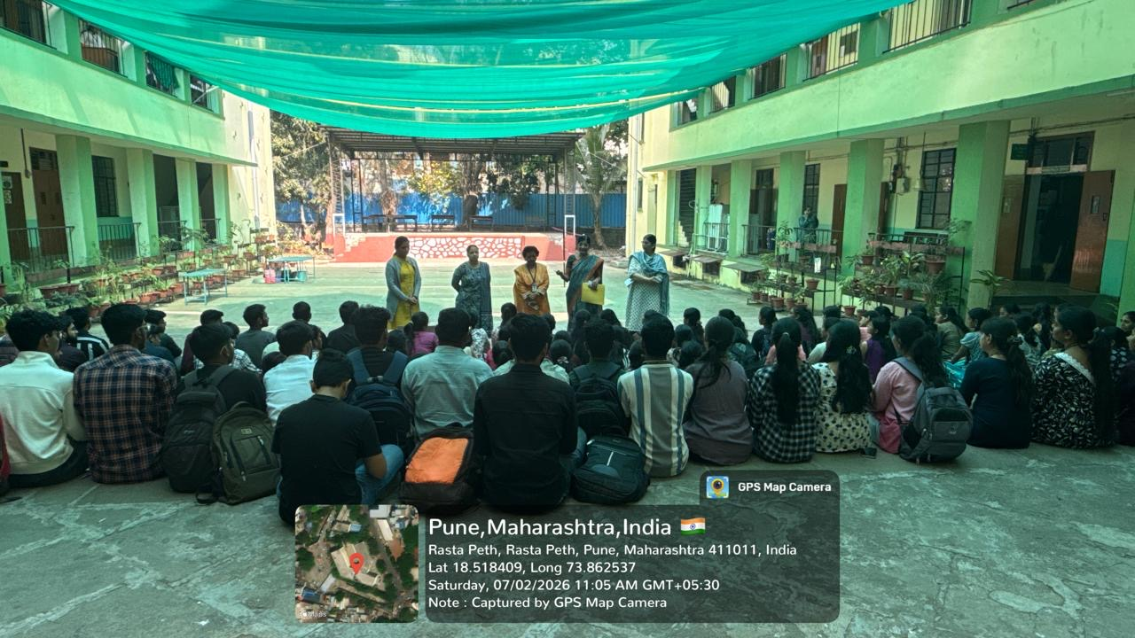
Pre-workshop Meeting
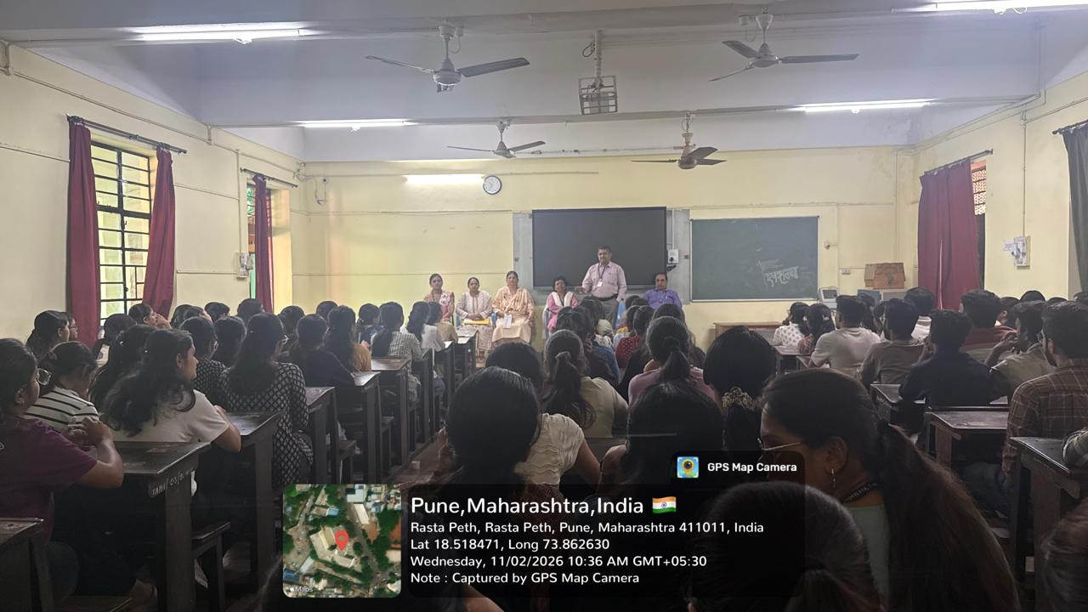
Workshop Inauguration

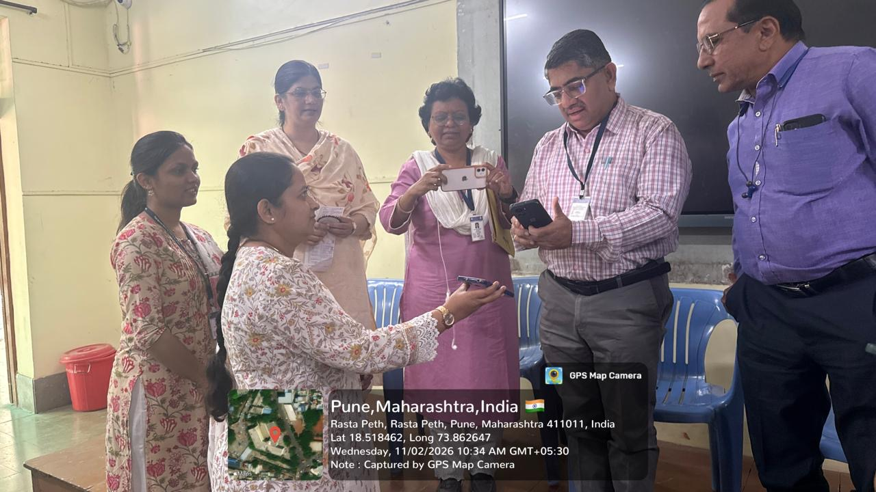
Scanning Of QR Code By Hon.Wise Principal Dr. Mihir Hajarnavis

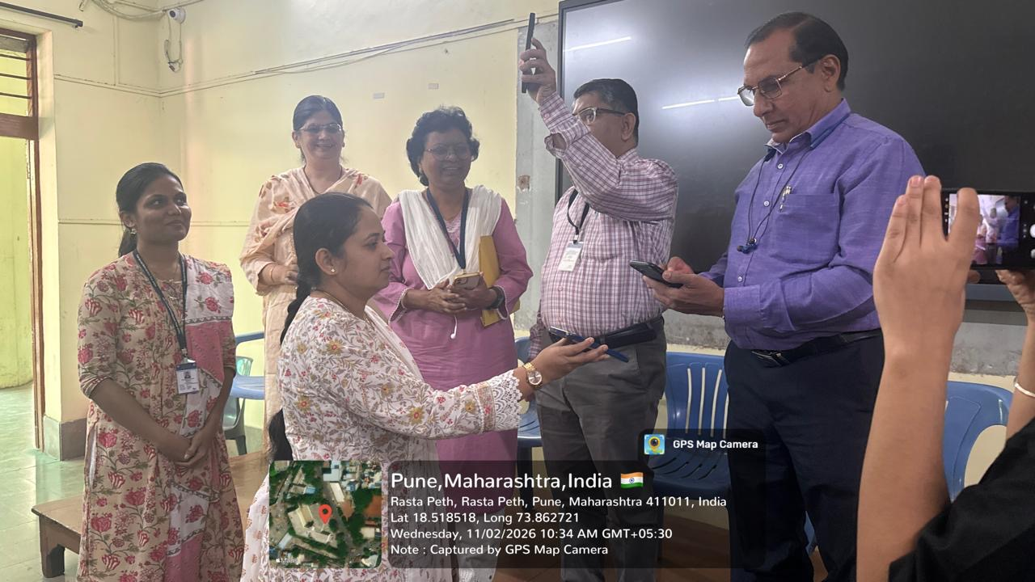
Scanning Of QR Code By H.O.D. Dept.of Shalyatantra Dr. Nandakishor Borse

