RSM’s Tilak Ayurved Mahavidyalaya, Pune
गीर्वाणवाणी वृन्द​ Geervaanavaani Vrunda
And
Department of Samhita Siddhant Evam Sanskrit

Report of Sanskrit Drama Competition

Every year R. N. Dandekar Sanskrit Drama Competition is organised by Fergusson College Pune. This was 26th year of the competition. It was held on 25/2/2026.
This year first year and second year B.A.M.S. students from Tilak Ayurved Mahavidyalaya’s Geervaanavaani Vrunda and Department of Samhita Siddhant Evam Sanskrit participated in the event. A 35 minutes long one act play was performed by students on 25/2/2026. The name of the play was “ग्रामनीति:” Four students from second year and 25 students from first year participated in the drama. The script was written and translated by students under the guidance of Dr. Madhura Kulkarni.
Dr. Saroj Patil, Principal and Dr. Ghanashyam Dongre, HOD, Department of Samhita Siddhant Evam Sanskrit supported and guided throughout the preparation and during the event.

The YouTube link of the play is –
https://youtu.be/ic6psvKeetw?feature=shared

Photos –
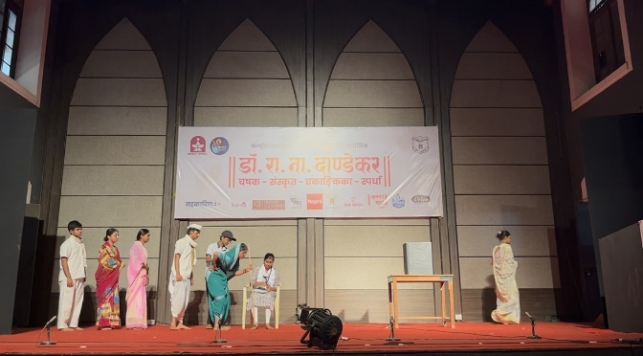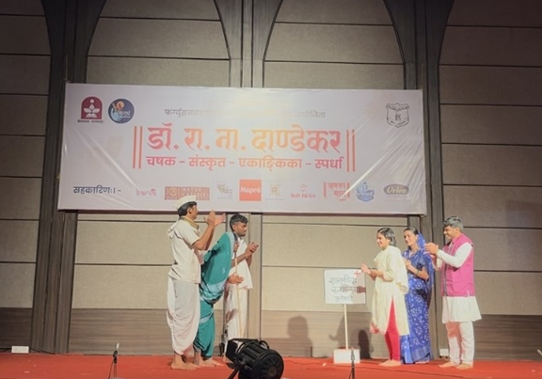
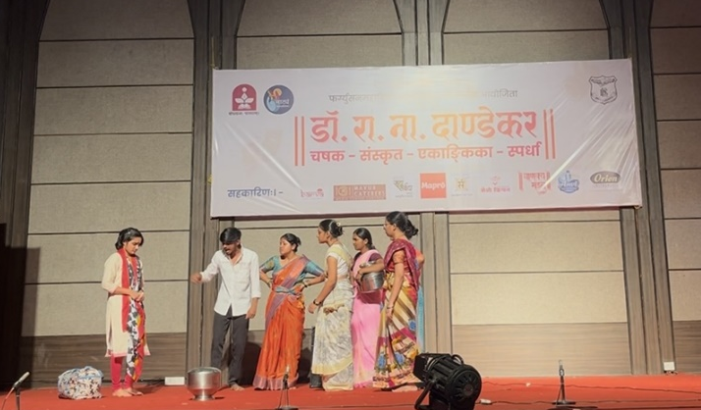

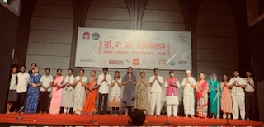

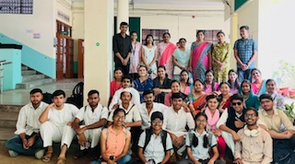

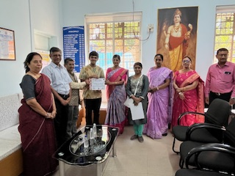

Dr. Madhura Kulkarni Prof. Dr. Ghanashyam Dongre
Assist. Prof. Sanskrit HOD
Geervaanvaani Vrunda Samhita Siddhant Evam Sanskrit Dept.

