Date: 06/03/2026

To
Principal
Tilak Ayurved Mahavidyalay,
Pune

Subject: Submission of report of Interdisciplinary activity of Department of Dravyaguna Vigyan with Department of Pharmacology, Symbiosis Medical College for Women, Lavale
Respected Madam,
On 5th March 2026, all faculties of Department of Dravyaguna Vigyan were invited as Medicinal plant expert for academic visit of total 150 Phase II MBBS students to the Medicinal Plants Garden at SIU Hilltop, Lavale Campus from 10:00 AM to 2:00 PM as a part of experiential learning under the Competency-Based Medical Education (CBME) curriculum. Here, the report of the same is attached along with photos. Kindly note. Thanking you.

Yours faithful

Dr. Apoorva Sangoram
Prof. and HOD
Department of Dravyaguna Vigyan

Interdisciplinary activity of Department of Dravyaguna Vigyan with Pharmacology Department, Symbiosis Medical College for Women, Lavale
On 5th March 2026, the Department of Pharmacology, SMCW organized an academic visit for total 150 Phase II MBBS students to the Medicinal Plants Garden at SIU Hilltop, Lavale Campus from 10:00 AM to 2:00 PM as a part of experiential learning under the Competency-Based Medical Education (CBME) curriculum. The initiative and purpose of educating MBBS students about medicinal plants was inspired by the vision of Mrs. Sanjeevani Mujumdar, Hon. Director, whose encouragement to integrate traditional knowledge with modern medical education played an important role in organizing this visit. All faculty members from the Dravyaguna Department, Tilak Ayurved Mahavidyalay, Pune, including Dr. Apoorva Sangoram (Professor and Head of the Department), Dr. Asmita Jadhav (Associate Professor), Dr. Pradnya Gathe (Associate Professor), Dr. Gauri Gangal (Assistant Professor), and Dr. Dewashish Umbrajkar (Assistant Professor) were invited to conduct academic session and guided tour of the medicinal plant garden at SIU Hilltop, Lavale. Dr. Shraddha Yadav, Dr. Gajanan Kulkarni, Dr. Ramanand Patil, other faculties and PG students of Department of Pharmacology were present to coordinate the session. The purpose of the visit was to provide medical students with practical exposure to medicinal plants and to enhance their understanding of their traditional uses, active constituents, and pharmacological relevance. During the visit, students were introduced to various medicinal plants and their botanical identification, Ayurvedic properties, phytochemical constituents, and therapeutic applications. The session was highly interactive, and students actively participated by asking questions and engaging in discussions regarding the role of herbal medicines in modern pharmacology. The visit proved to be an enriching learning experience and helped students appreciate the importance of medicinal plants in healthcare and drug development.
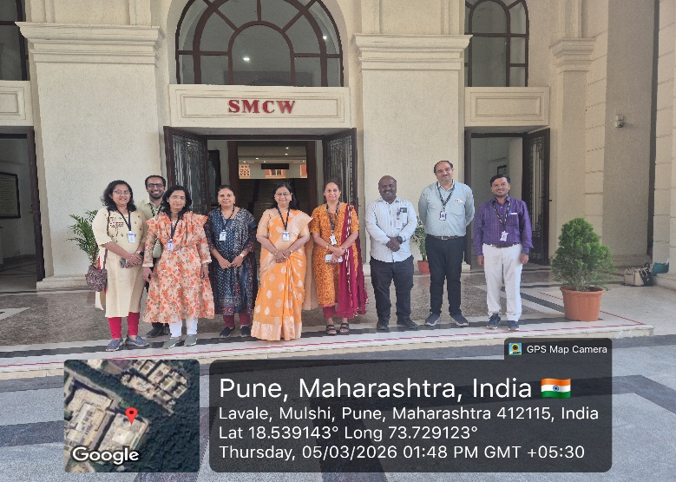 | 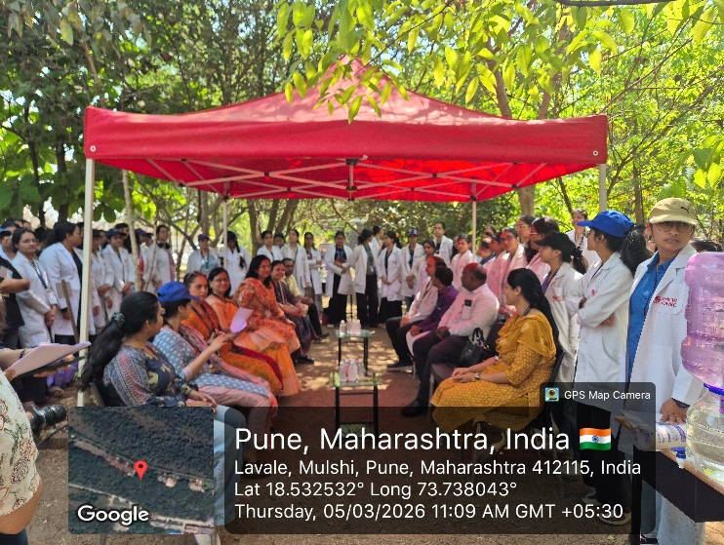
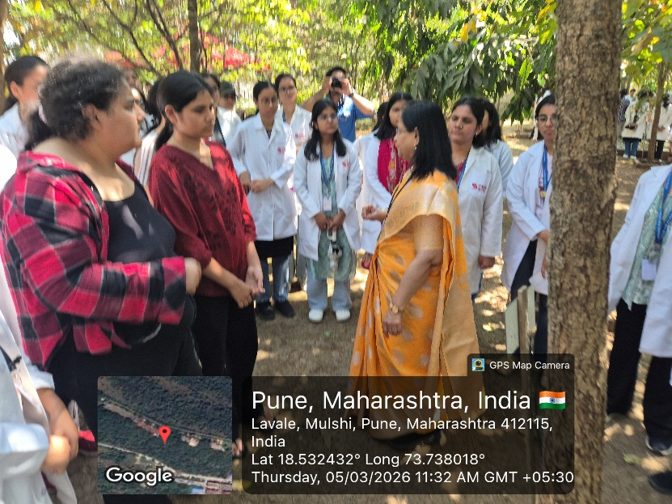 | 