Departmental Workshop
On
Digitalisation & Model Making of Yantras: Feb.2026

“Workshop Report”

NAME OF EVENT:
DEPARTMENTAL WORKSHOP: Digitalisation & Model Making of Yantras

ORGANIZED BY: KAI.SHRI.AA. MANDKE DEPARTMENT OF RASASHASTRA, T.A.M.V.
DATE OF EVENT: 25TH Feb.2026
OBJECTIVE & DESCRIPTION:
Kai.shri.A.Mandke Dept. of Rashashastra organized a workshop titled “Digitalisation & Model Making of Yantras” on 25th feb. 2026.

The workshop includes theory lectures as well as hands on training with demonstrations of QR code making of pharmacological information of different yantras in ayurveda pharmaceutics and oral Presentations of the same by participating students.

This will encourage II B.A.M.S. students & P.G. scholars of the of the institute to develop their Digital skills and Knowledge regarding Yantras used in ayurveda pharmacy.

The competency-based curriculum by NCISM and M.U.H.S. encourages organization of such activities which will be useful for further career development of Undergraduate Students.

This event was carried out during college hours. A prior permission for the conduction of workshop from the Respected Principal Dr. Saroj Patil was taken and documented.
Also, a prior Informing Notice regarding the conduction of this workshop for the H.O.D.s & Faculties of the second professional B.A.M.S. Batch, appearing in the month of September 2026 was circulated and attendance of the participating Students in this workshop was shared with concerned departments as per regular time table.

RESOURCE PERSON:
- Prof. Dr. Indira Ujagare
- Prof. Dr. Vinaya Dixit
- Prof. Dr. Mandar Akkalkotkar
- Prof. Dr. Ashwini Bodade
- Prof. Dr. Kshitija Kulkarni

PG SCHOLARS:
All Post Graduate Scholars of Rasashastra Department

SCHEDULE OF THE WORKSHOP
Date- 25th Feb. 2026
Venue: Dept. of Rasashastra, T.A.M.V.
Time: 9.00 to 5.00 pm
Time | Topic | Resource Person
9.00-10.00 am | Concept to Pharmacy of Yantras in Ayurvedic Pharmaceutics | Dr.Vinaya Dixit
10.00-01.00 pm | Grouping & Model Making of Ancient Yantras | Dr. Ashwini Bodade  Dr. Kshitija Kulkarni
01.00-1.30 pm | Lunch Break | -
1.30-2.30 pm | Applied Aspect & Significance of Yantras | Dr.Indira Ujagare
2.30-5.00 pm | Exhibition & Display of Prepared Models. | Dr.Mandar Akkalkotkar  Dr.Kshitija Kulkarni

STUDENTS:
Participating Students:
- Batch September 2026 Appearing
- Batch March 2027 Appearing

GROUPS & ALLOTMENT:
124 students from II Year, appearing in September 2026 were divided into group of 10. Each Group was allotted with 5 Yantras.
Group leaders were allotted for respected groups. These group leaders reported to respective Guides and both were instructed by respective Mentors.

Topics allotted: Ayurveda & Modern Yantras from Rasashastra as per NCISM syllabus for Second Professional B.A.M.S.

PROCUREMENT OF FUNDS: Departmental Cash Pool.
DOCUMENTS PREPARED BY STUDENTS:
- “QR CODE” personalized to each Yantras.
- Copies of Detail Description regarding Reference, uses, Structure and
Diagram of Yantras.

INAUGURATION:
On 25th February 2026, inauguration of workshop was done by Hon. Principal Prof. Dr. Saroj Patil, Vise Principal Prof. Dr. Mihir Hajarnavis, Vise Principal Prof. Dr. Sangeeta salvi, Vise Principal Prof. Dr. Minakshi Randive in classroom no.2 of Tilak Ayurveda Mahavidyalaya in the presence of Faculties of department of Rasashastra namely Prof. Dr. Indira Ujagare, Prof. Dr. Vinaya Dixit, Prof. Dr. Ashwini Bodade, Prof. Dr. Kshitija Kulkarni, and participating students.

Inauguration was done by Making & Labelling of Model of Dola Yantra, by the hands of Hon. Principal Prof. Dr. Saroj Patil followed by his guiding and encouraging words mentioning the importance of Rasashastra in clinical practice of ayurveda.
Hon.Vice Principal Prof. Dr. Sangeeta salvi , Hon.Vice Principal Prof. Dr. Minakshi Randive & Hon.Vice Principal Prof. Dr. Mihir Hajarnavis sir equally motivated all the students with their valuable guidance about the future scope of entrepreneurships in ayurveda pharmaceutics and expressed their wishes for the workshop.

The Inaugural Function was concluded by Hon. H.O.D. declaring that the ready QR Codes will be displayed along with Yantras in Museum of Rasashastra department.

DOCUMENTS ATTACHED WITH REPORT:
- Sample of QR Code
- Photographs

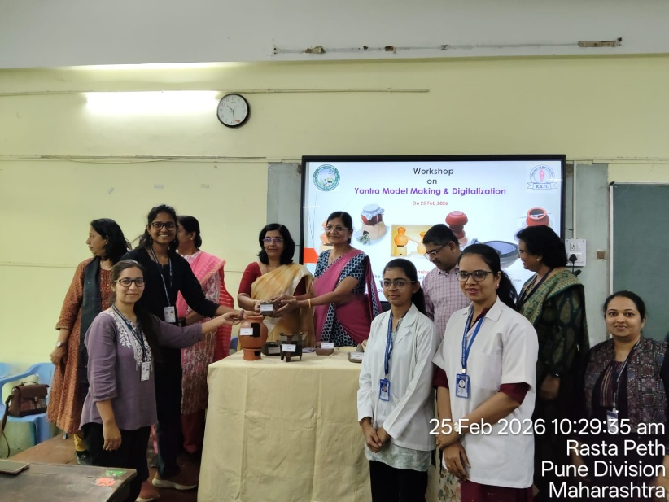
Inauguration of Workshop by the hands of Hon. Principal Dr. Saroj Patil
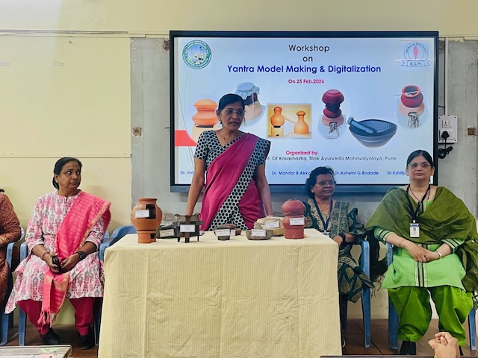
Motivating Words by Hon. Principal Dr. Saroj Patil

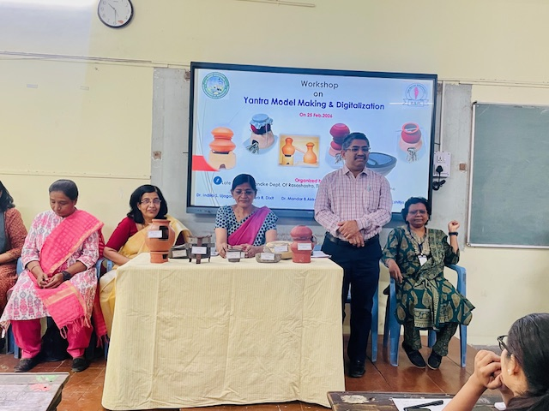
Guidance by Hon.Vice Principal Dr. Mihir Hajarnavis

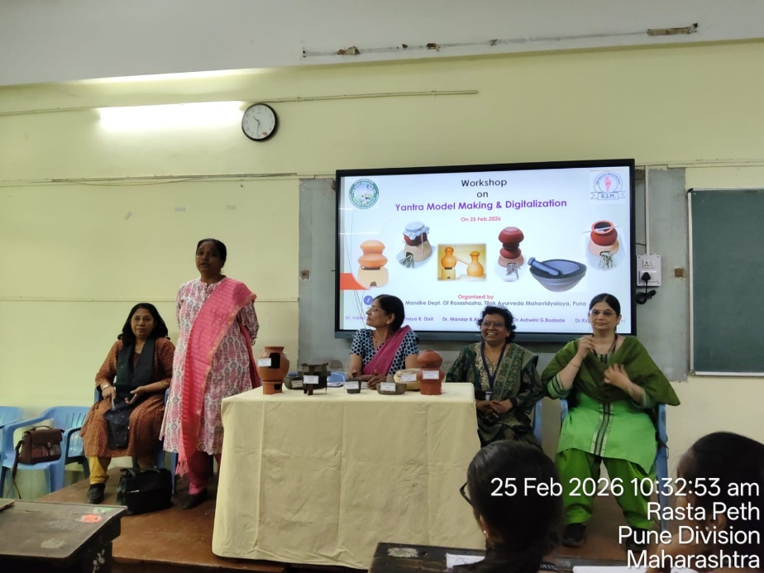
Guidance By Hon.Vice Principal Dr. Sangeeta Salvi

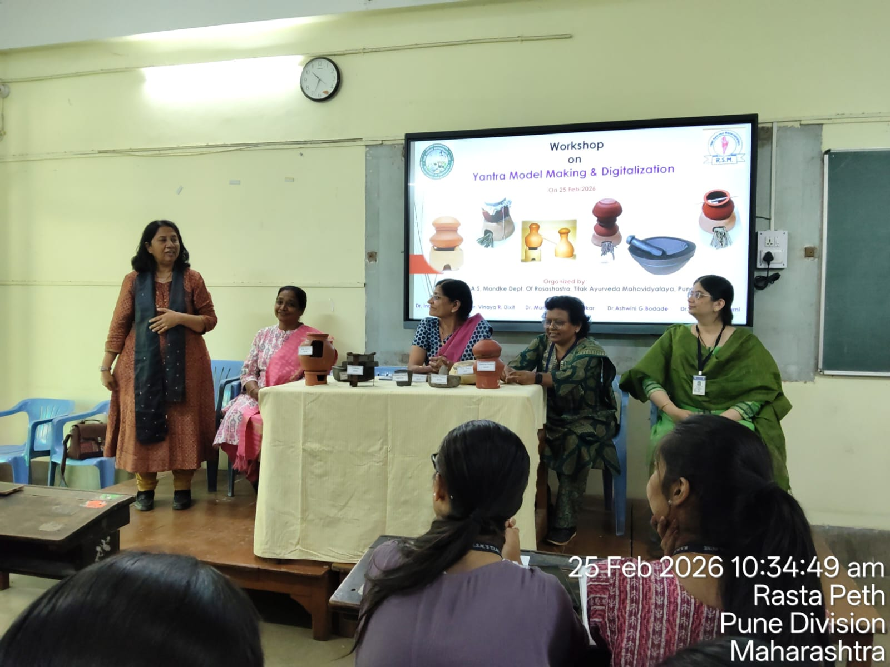
Guidance By Hon.Vice Principal Dr. Minakshi Randive

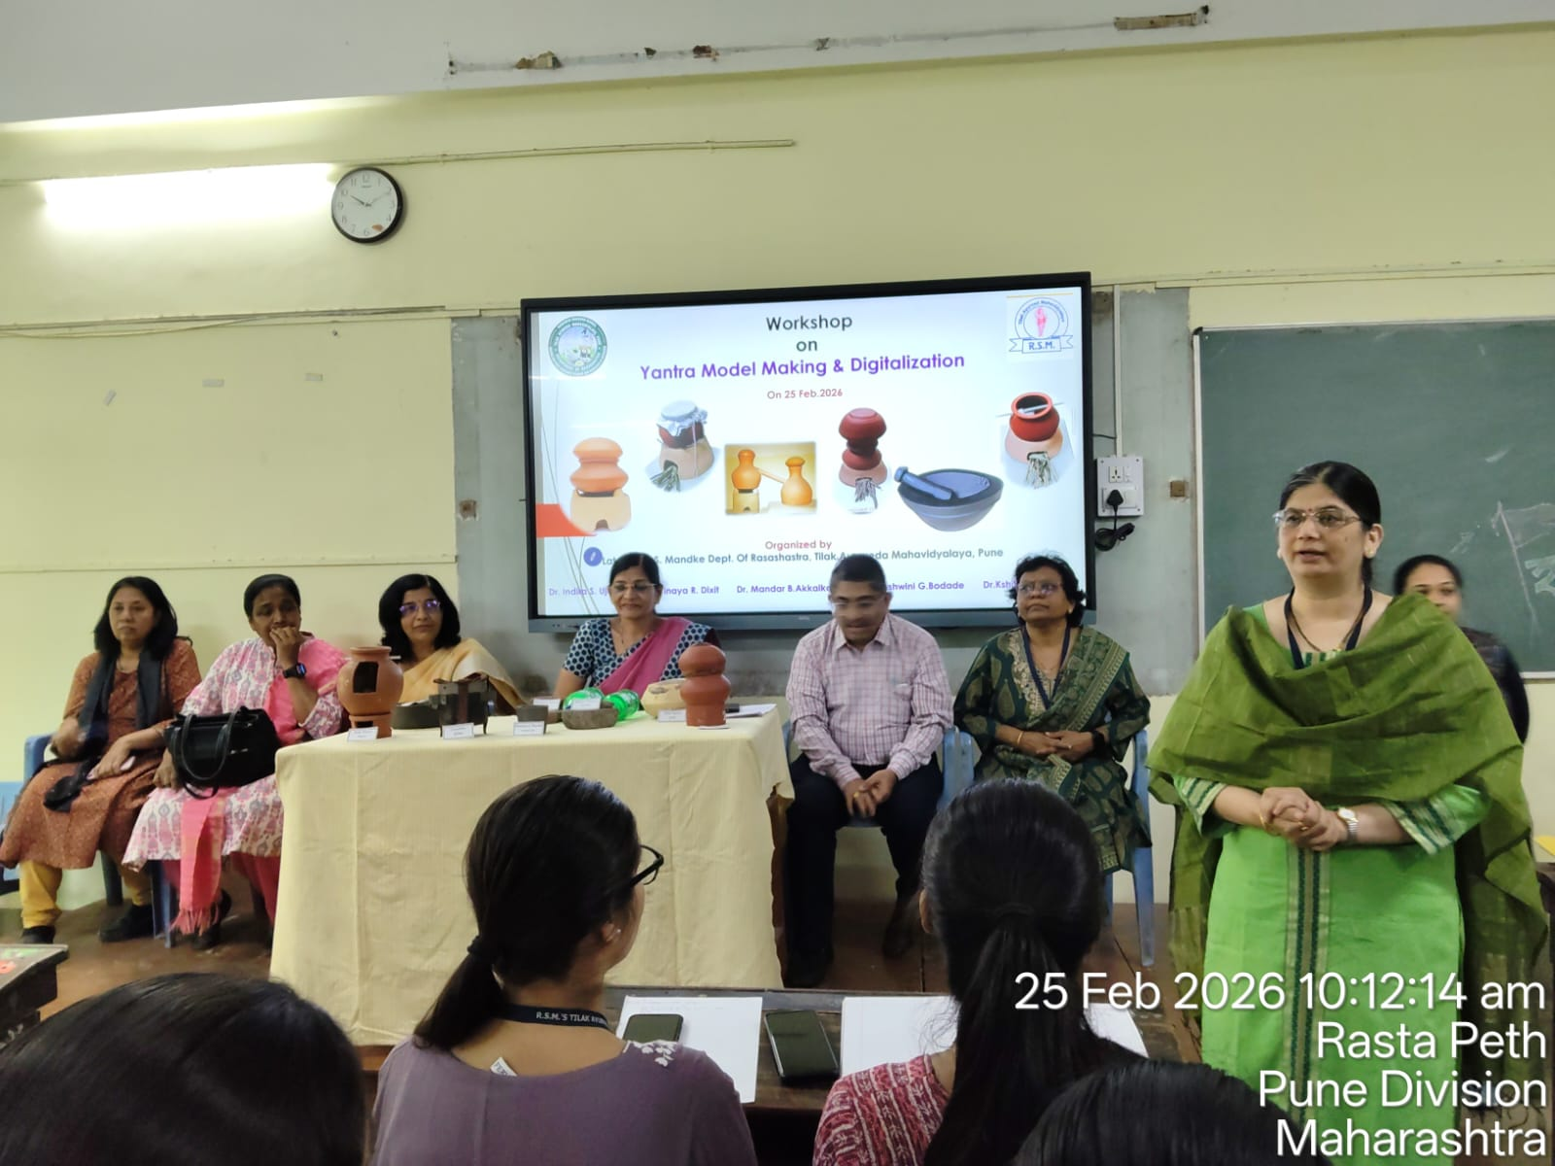
Anchoring of Workshop by Prof. Dr.Vinaya Dixit

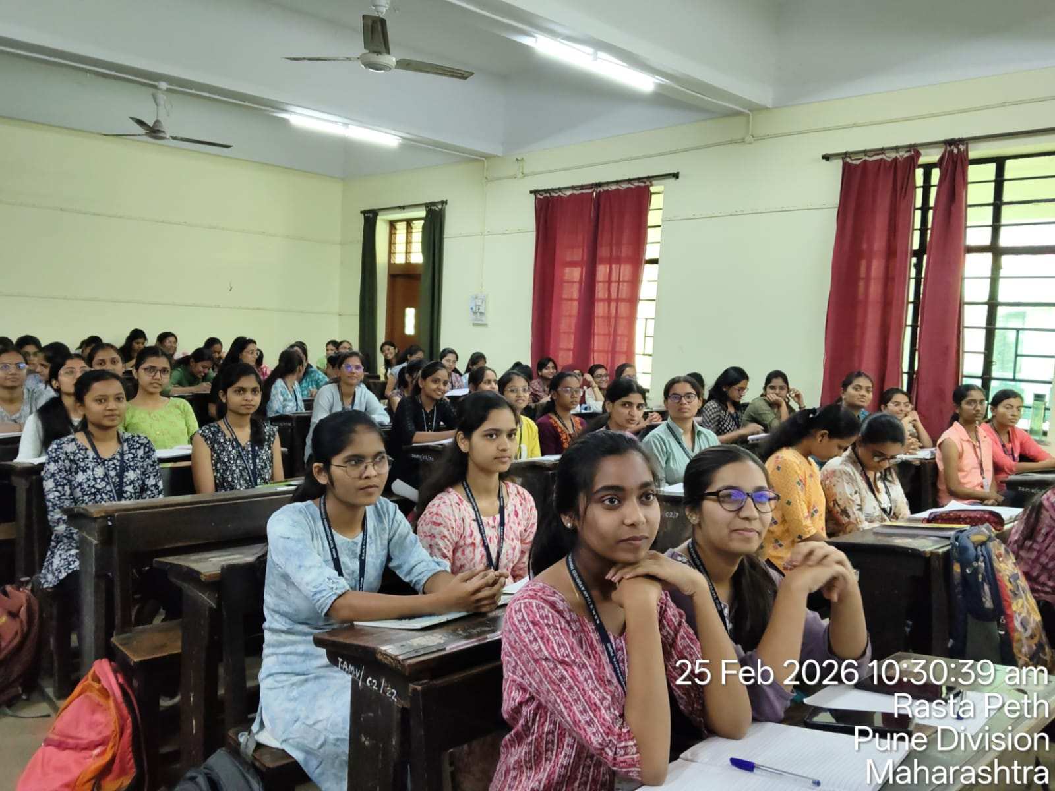
Participants in Workshop : Students of II B.A.M.S.

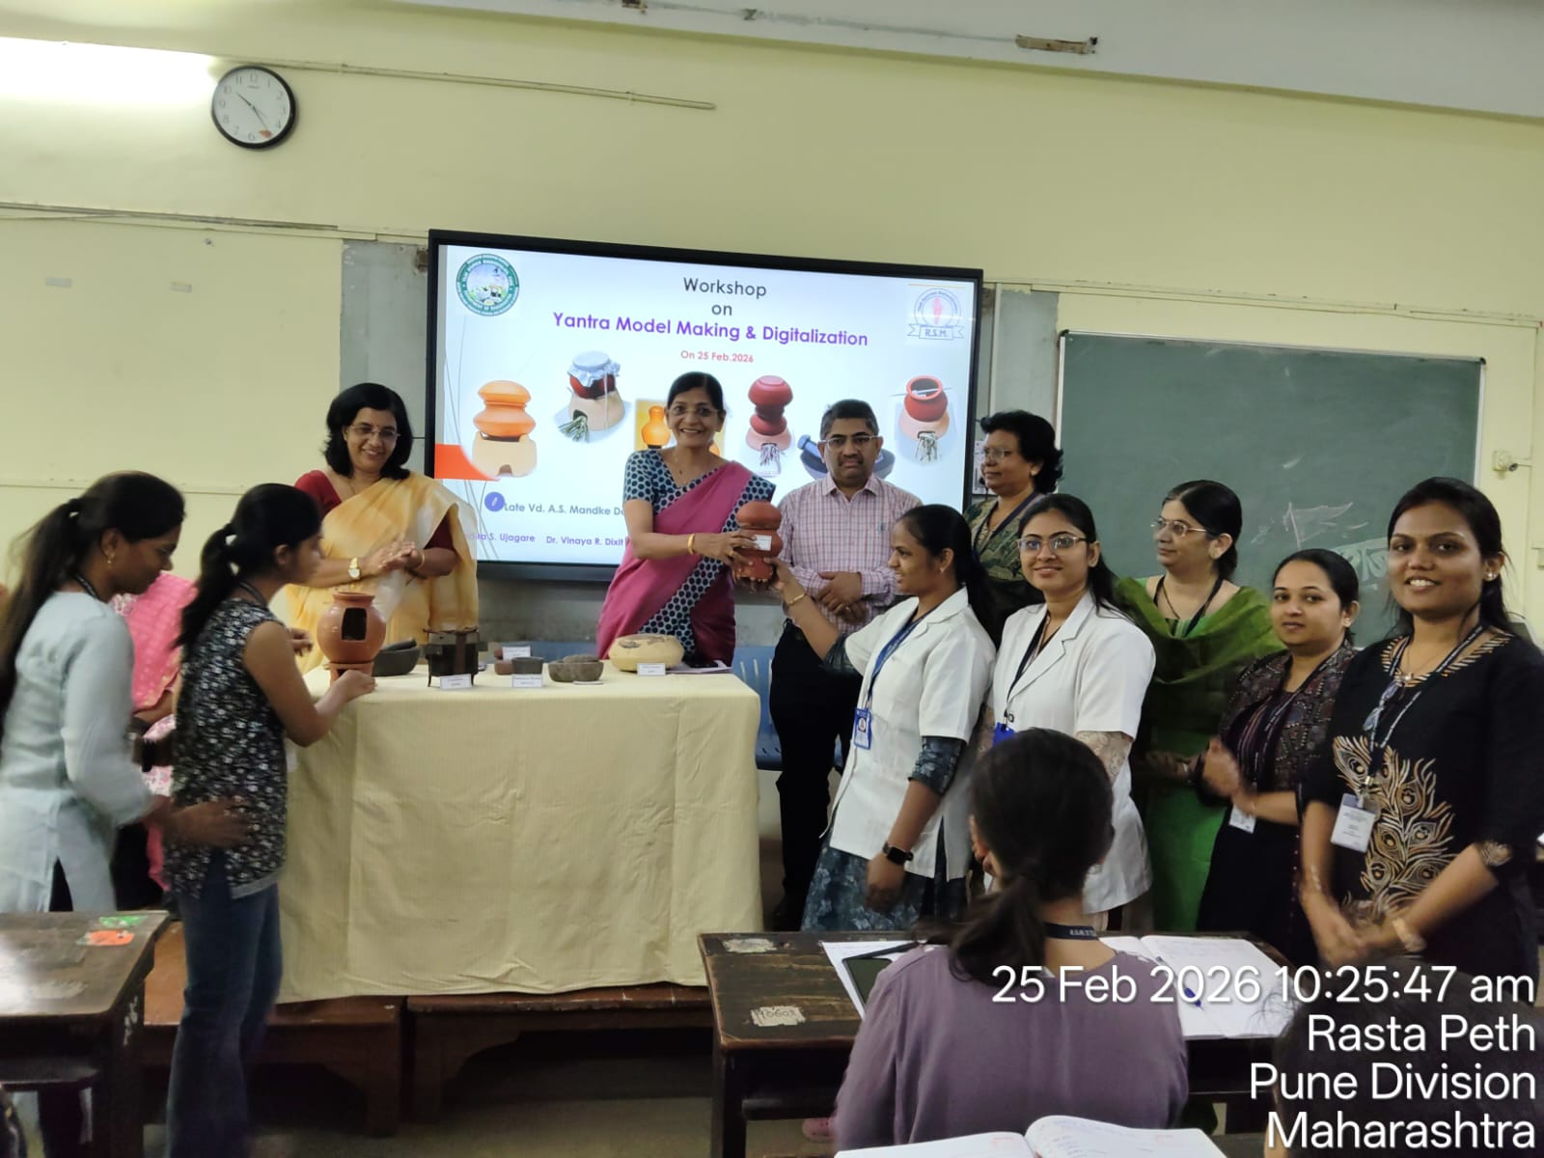
Participants in Workshop : PG Scholars, Dept.of Rasashastra
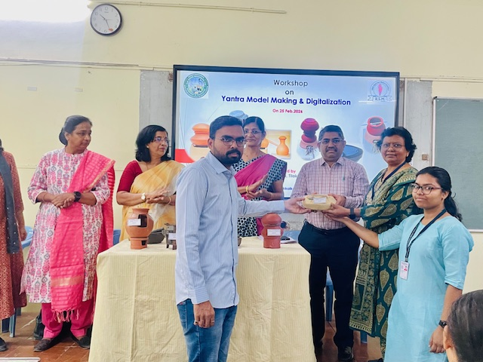
Participants in Workshop : PG Scholars, Dept.of Rasashastra
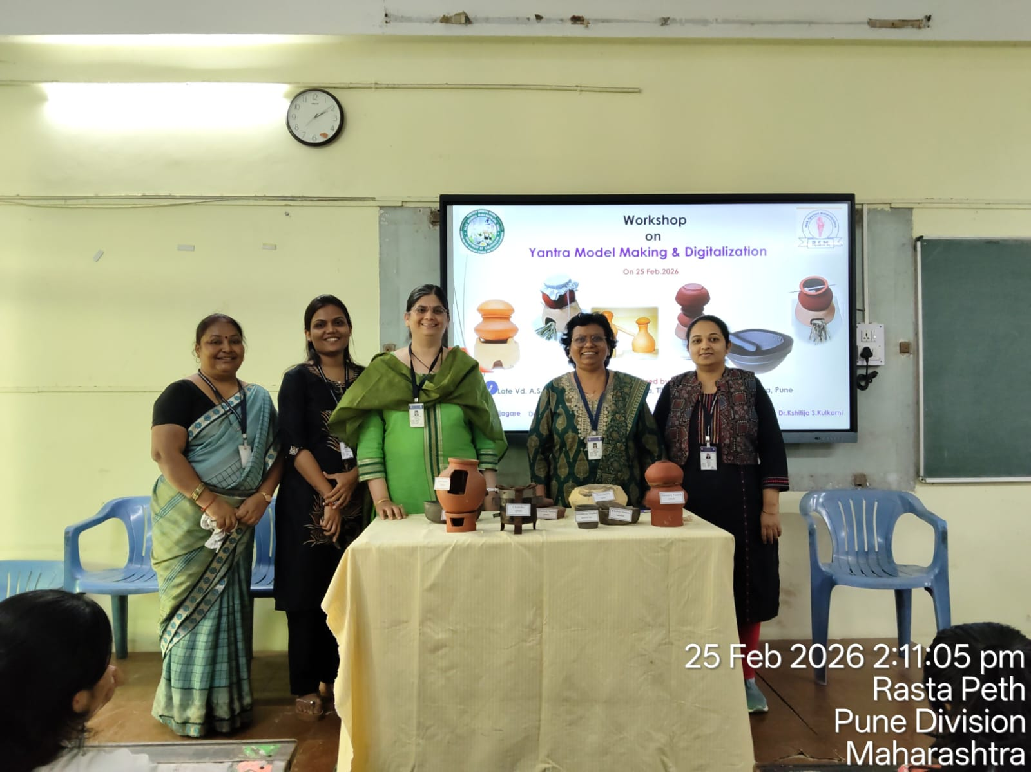Resource Person of Yantra Model Making & Digitalisation of Workshop : Non- Teaching Staff & Faculties of Department of Rasashastra
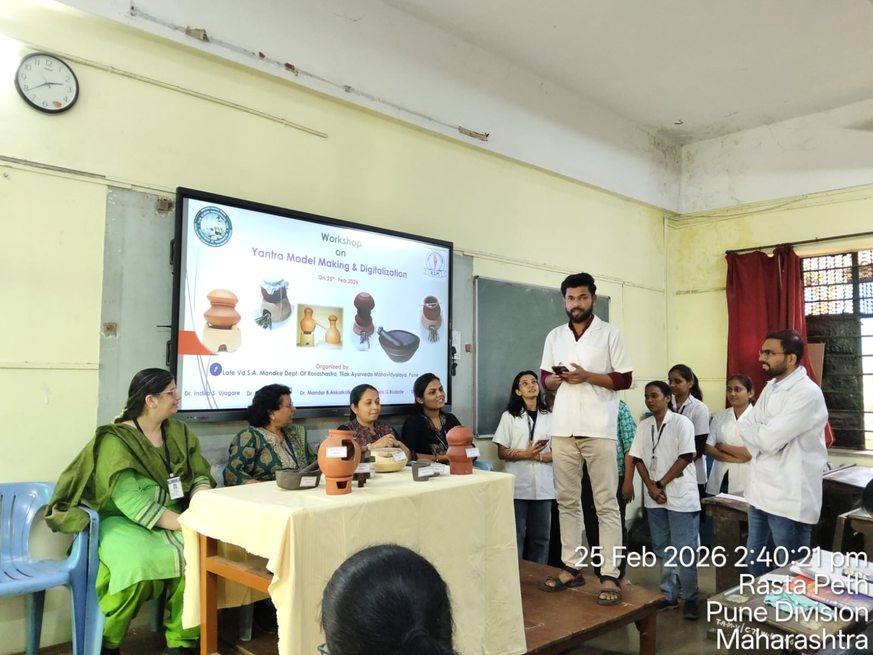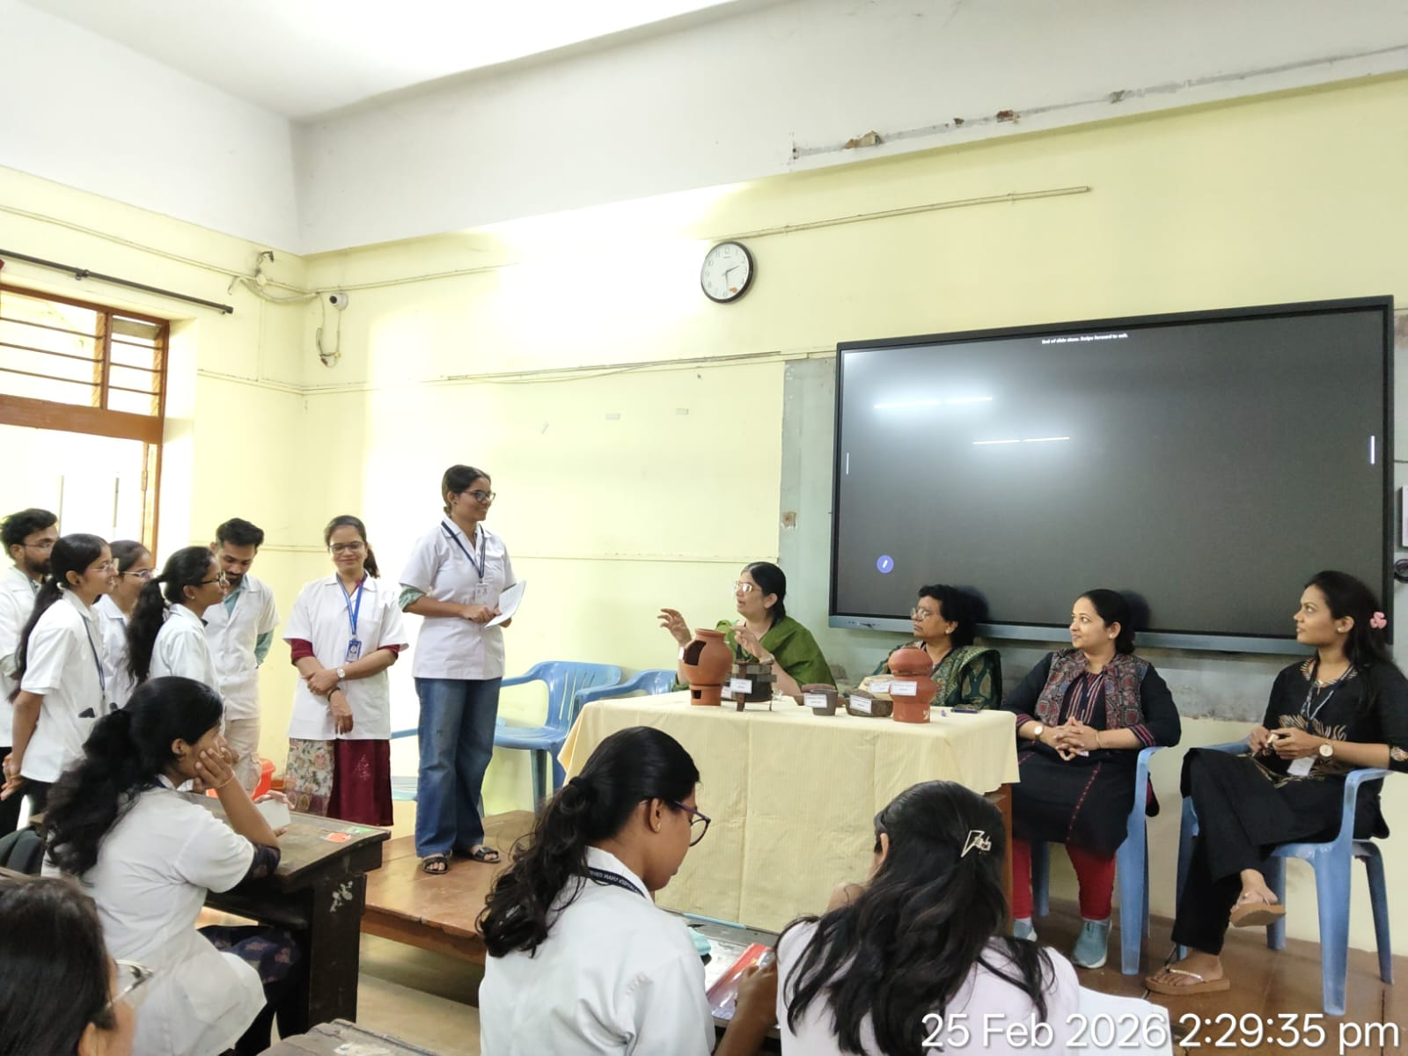Presentations by Participants

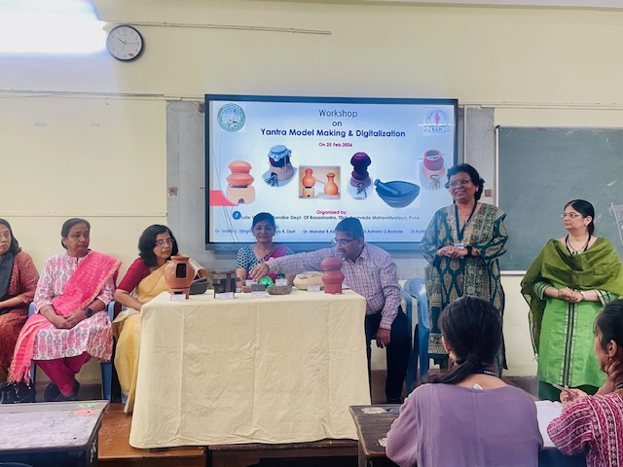
Concluding words by Prof. Dr. Indira Ujagare, H.O.D. Dept. Of Rasashastra
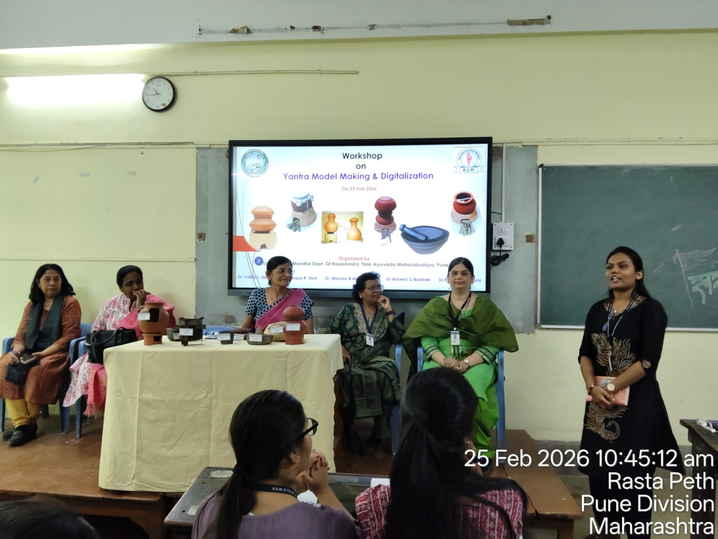
Vote of Thanks by Dr. Kshitija Kulkarni
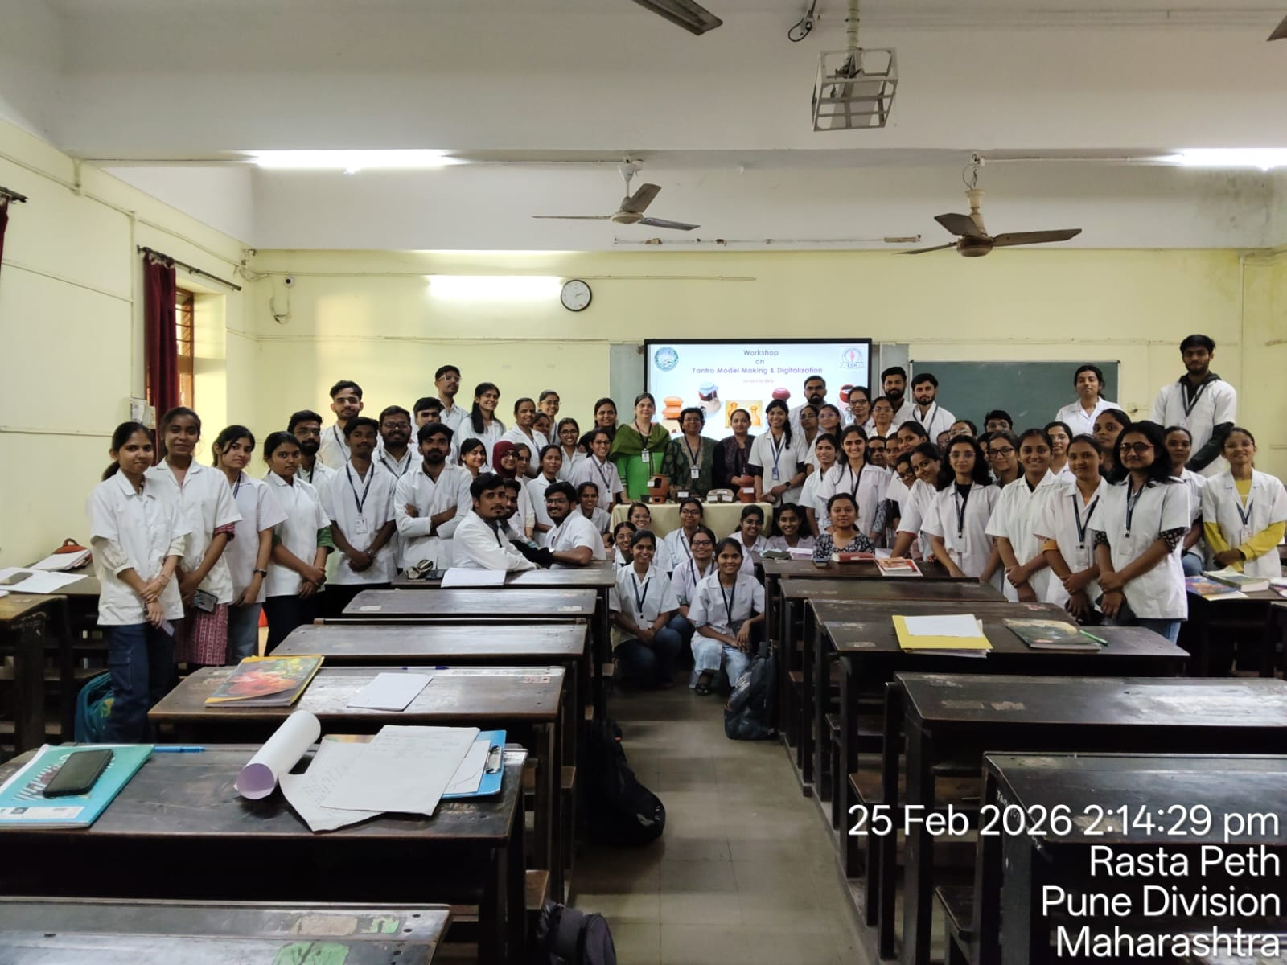
Successful Completion of Workshop : Resource Person & Batch of II B.A.M.S.
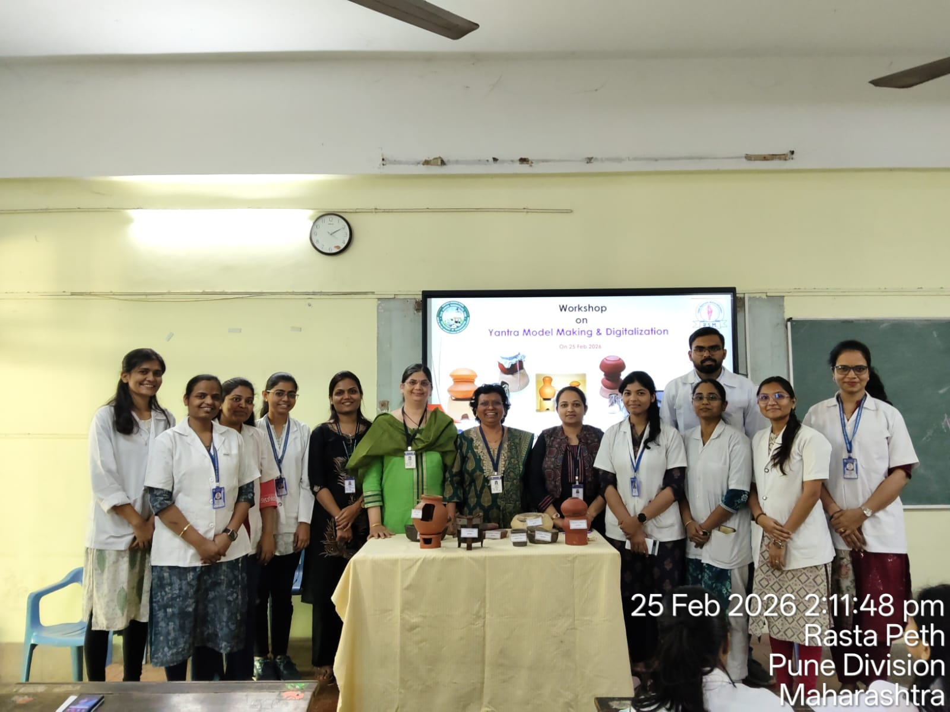
Successful Completion of Workshop : Resource Person & PG Scholars of Dept. of Rasashastra

